# A digital twin-based implementation of goat health monitoring System.

|  |  |  |  |
| --- | --- | --- | --- |
| **Undergraduate Final Year Project Report**  IMG-20180516-WA0003   |  |  |  | | --- | --- | --- | |  |  |  | |
| Muhammad Haseeb FA20-BCE-063  Muhammad Irfan FA20-BCE-091  Zubair Ahmed Rana FA20-BCE-094  **Project Supervisor:** Dr. Jehangir Arshad **Co-Supervisor:** Dr.Arsla Khan  SPRING 2024 |
| |  | | --- | | **COMSATS UNIVERSITY ISLAMABAD, LAHORE CAMPUS, PAKISTAN** | |
|  |

|  |  |  |  |  |  |  |
| --- | --- | --- | --- | --- | --- | --- |
| **PROJECT ID** | |  | |  | **NUMBER OF MEMBERS** |  |
|  | | | | | | |
| **TITLE** |  | | | | | |
|  | | | | | | |
| **SUPERVISOR NAME** | | | TERNAL / EXTERNAL | | | |

|  |  |  |
| --- | --- | --- |
| **MEMBER NAME** | **REG. NO.** | **EMAIL ADDRESS** |
|  |  |  |
|  |  |  |
|  |  |  |
|  |  |  |

**CHECKLIST:**

|  |  |  |  |
| --- | --- | --- | --- |
| Number of pages in this report |  |  |  |
| I/We have enclosed the soft-copy of this document along-with the codes and scripts developed by myself/ourselves | **YES / NO** | | |
| My/Our supervisor has attested the attached document | **YES / NO** | | |
| **I/We confirm to state that this project is free from any type of plagiarism and misuse of copyrighted material** | **YES / NO** | | |
|  |  | | |

|  |  |  |
| --- | --- | --- |
| **MEMBERS’ SIGNATURES** |  | |
|  |  | Supervisor’s Signature |
|  |  |
|  |  |
|  |  |

Note 1: This paper must be signed by your supervisor

Note 2: The soft-copies of your project report, source codes, schematics, and executables should be delivered in a CD

**This work, entitled “A digital twin based implementation of goat health monitoring System” has been approved to fulfil partial requirements for the award of**

**BS in Computer Engineering to**

Muhammad Haseeb FA20-BCE-063

Muhammad Irfan FA20-BCE-091

Zubair Ahmed Rana FA20-BCE-094

SPRING 2024

**External Examiner:**

**Head of Department:**

Department of Electrical and Computer Engineering

COMSATS UNIVERSITY ISLAMABAD

LAHORE CAMPUS– PAKISTAN

**Declaration**

*“No portion of the work referred in this report has been submitted in fulfilment of another degree or qualification for any other institute or university”.*

|  |
| --- |
| **MEMBERS’ SIGNATURES** |
|  |
|  |
|  |
|  |

**Acknowledgements**

In the name of God, the most kind and most merciful

We would like to thank our family and friends who kept always supporting us, both financially and morally. They believed in us, which helped us mentally and made us strong to achieve our ambitions with full determination.   
Most importantly we would like to thank our project supervisor Dr. Jehangir Arshad, none of this would’ve been possible without his consistent guidance and support. Also, our co-supervisor, Dr. Arsla Khan who constantly motivated us.

Lastly, we would like to thank our department and institution for providing us with an ideal and experienced faculty for being cooperative, and for understanding our needs throughout this program. It was a pleasure being part of this institute and the department, which contained brilliant faculty members, who guided us all the way throughout the program.

We are thankful to ALLAH Almighty for giving us access to all resources of every kind so that we can use them wisely for the good of humanity. May He continue to give us all the skills and direction we need to continue serving humanity.

**Abstract**

Across digital technologies that are now essential in agriculture and livestock production, animal welfare cannot be missing. The following is a state-of-the-art based project related to health monitoring of goats by the implementation of Digital Twin-based System. Digital twins will digitalize the goat and through a two-way dossier we can control them as they should be, paramount in real time. The 3 above systems uses IOT devices, wearable sensors and cloud computing which can be used as building blocks to develop Digital Twins for every goat in a flock so designed using any of the above principals. All day long they work collecting and crunching infinite health data, like vitals, activity levels, feeding times -the list seems to go on and on.This data is then processed through machine learning algorithms to identify anomalies and predict potential health issues for proactive veterinary interventions. The smart monitoring system makes goat farming more efficient through the ability to deliver precise, individual treatment. With the friendly interface in use, farmers have a deep insight into a health status of theirs livestock or historical trends throughout their whole herd.That not only helps in the early diagnosis of diseases but also efficient resource utilisation and hence increased franchisee productivity and sustainability. Intelligent Goat Health Monitoring System Powered with Digital Twins is thus a significant step-up in precision agriculture, promoting live beef cattle and assisting ranchers to secure their investmentsthroughwell-informedchoices.

Table of Contents

A digital twin-based implementation of goat health monitoring System. i

1 Introduction: 9

2 Literature Review: 14

3 Proposed Methodology 24

3.1 System Overview 26

3.2 Hardware Details: 27

3.2.1 ESP32: 28

3.2.2 MQ135 Gas Sensor: 29

3.2.3 DHT22 Temperature and Humidity Sensor: 30

3.2.4 ADXL345 Accelerometer: 30

3.2.5 MAX30102 Pulse Oximeter and Heart-Rate Monitor: 31

3.2.6 DS18B20 Sensor: 32

3.3 Dataset Working: 33

3.3.1 Data Collection: 33

3.3.2 Data Processing: 34

3.3.3 Health Monitoring: 34

3.3.4 Alert Generation: 35

3.3.5 Data Logging and Analysis: 35

3.3.6 Feedback and Intervention: 35

3.4 Software Details 35

3.4.1 AWS cloud 35

3.4.2 Aws IoT twin maker 36

3.5 Application of digital twin 36

3.5.1 Virtual Representation of Goats 36

3.5.2 Health Monitoring and Predictive Analytics 36

3.5.3 Environmental Simulation 37

3.5.4 Precision Farming 37

3.5.5 Decision Support System 37

3.5.6 Remote Monitoring and Control 37

3.5.7 Data Integration and Visualization 37

3.6 Integration of hardware and digital twin 37

3.6.1 Sensor Integration 37

3.6.2 IoT Devices 38

3.6.3 Communication Protocols 38

3.6.4 Modelling the Physical System 38

3.6.5 Real-time Data Integration 38

3.6.6 Analytics and Decision Support 38

3.6.7 Remote Monitoring and Control 38

3.6.8 Historical Data Storage 38

3.6.9 Dashboard and Visualization 39

3.6.10 Alerts and Notifications 39

3.7 Wireless Body Area Network (WBAN) 39

4 Implementation 40

4.1 Wireless Body Area Network 40

4.2 Machine Learning Model 41

4.2.1 Random Forest Classifier 42

4.3 Random Forest Classifier Working 43

4.3.1 Training 43

4.3.2 Calculating Class Probabilities 44

4.3.3 Prediction 44

4.3.4 Assumptions of Random Forest 44

4.3.5 Benefits and Limitations 45

4.4 Mobile Application 45

4.4.1 Splash Screen 46

4.5 Login Page 47

4.6 Signup Page 48

4.7 OTP Screen 50

4.8 Forget Password Screen 51

4.9 Reset Password Screen 51

4.10 Goat Health Monitoring Device 52

5 Evaluation 54

5.1 Comparative Analysis 54

5.1.1 Analysis 54

5.2 Random Forest Classifier 58

5.2.1 Random Forest Accuracy vs Number of Trees 59

5.2.2 Random Forest Error Rate vs Number of Trees 60

5.3 Goat’s Digital Twin 61

5.4 Mobile Application 62

6 Conclusion & Future Work 64

6.1 Conclusion 64

6.2 Future Ideas 64

7 References 65

8 Appendix A: Sustainable Development Goals Achievement 69

9 Appendix B: HDL or C Source Code 70

10 Appendix C: Hardware Schematic 76

11 Appendix D: List of Hardware Components 77

**Table of Figures**

Figure 1.1 System Overview diagram of goat health monitoring system 13

Figure 3.1 Block Diagram of Digital Twin 25

Figure 3.2 Block diagram 26

Figure 3.3 ESP32 28

Figure 3.4 MQ-135 28

Figure 3.5 DHT22 29

Figure 3.6 ADXL345 30

Figure 3.7 MAX30102 31

Figure 3.8 DS18B20 32

Figure 3.9 Dataset Collection 33

Figure 3.10 Disease Prediction 34

Figure 4.1 Circuit diagram 41

Figure 4.2 Main Page 45

Figure 4.3 Splash Screen 46

Figure 4.4 Login Page 48

Figure 4.5 Signup Page 49

Figure 4.6 OTP Screen 50

Figure 4.7 Forget Password Screen 51

Figure 4.8 Reset Password Screen 52

Figure 5.1 Training Errors 55

Figure 5.2 Test Errors 55

Figure 5.3 ROC Curve 56

Figure 5.4 Random Forest Accuracy vs Number of Trees 60

Figure 5.5 Random Forest Error Rate vs Number of Trees 60

Figure 5.6 Digital Twin of Goat 62

Figure 5.7 Result Screen 63

Figure 0.1 Hardware Schematic 76

Table 2.1 Literature review summary 23

Table 3.1 Hardware details 26

Table 3.2 Characteristics of ESP32 27

Table 3.3 Characteristics of DHT22 29

Table 3.4 Characteristics of ADXL345 30

Table 3.5 Characteristics of MAX30102 31

Table 3.6 Characteristics of DS18B20 32

Table 5.1 Accuracy for the model trained 55

# Introduction:

Sustainable Development Goals (SDGs) developed by the United Nations for addressing several global issues and creating a better tomorrow for all of us. The 2030 agenda for sustainable development with its 17 SDGs seeks to achieve these goals by the year 2030. In order to sustainably address water and food shortages, they also highly encourage the promotion of sustainable farming, resilient supply chains, universal access to resources, and work on effective water management plans with a focus on the goals such as clean drinking-water and sanitization. The SDGs aim to synchronize technology and daily living to produce a more sustainable and resilient future for everybody. Our proposed architecture aims to play a vital role in attaining the Sustainable Development Goals (2,3,9,12 and 15) listed by the United Nations, i.e., Zero hunger, Good Health and Well-being, Industry, Innovation, and Infrastructure, Responsible Consumption and Production and life on land, respectively.

Our Goat health monitoring system designed is capable enough to play a huge role in achieving goals for these SDGs. Farms integrated with our intelligent system would mean the farms can function at their full potential which will result in huge profits, minimum losses, and sustainable farms. Farmers can have stable incomes to support their families and produce enough to cover any food shortages in the market. Responsible consumption and production can be promoted in the agriculture field when there are no huge losses of animals, and it can be predicted beforehand if we are headed towards a shortage which will result in responsible consumption. Goats are an essential component of agriculture worldwide, and they have a particularly large population and economic impact in parts of Asia and Africa. This fact shows how important goats are for the livelihoods of rural communities, and indeed we know that there are probably more than a billion goats worldwide according to statistics from the Food and Agriculture Organization (FAO). Economic importance of goats contributes a major part in economics as they provide us meat, milk and fibre. The popularity of goats in regions such as South Asia and the Middle East, where there is a huge demand for goat products, means that goat farming has become a significant part of the agricultural economy in some regions. Several ethnic cuisines rely on goat meat for nutrition. Its worldwide demand rises the value of goat meat. Meat of which is important in the agricultural sector, goat meat, milk and fiber. Additionally, goat milk is gaining popularity due to its nutritional benefits and digestibility of protein (especially in health conscious and lactose illiberal audience). Two, the goats are economically more important as goats have fibers like cashmere and mohair which has high commercial value in the textile industry [1].

The vitality of the goats is important for these farms to be efficient and productive The color of the goat determines how healthy it is or not and also shows if it needs intervention to prevent an illness for the welfare state. In this section, we are going to talk about health monitoring in goat farming its application in veterinary medicine and general animal management. It also covers limitations of traditional monitoring techniques.

Goats are the heart of every goat farming operation, and healthy goats are necessary if you will succeed. Regular health observation assists in timely recognition of diseases as well as management of herd heath contributing, to the mitigation of deadly diseases that could spread across thousands of cattle. This is particularly important to prevent spoilage in foods like milk and meat. Keeping animals healthy, through health monitoring such as regular checks, vaccinations and control of parasites, is vital to ensuring animal welfare and financial farm productivity. In the preceding years, monitoring the health of goats was mostly performed through visual inspections and managing diseases reactively.

Among the management practices of goat farming, routine health monitoring measures are necessary to maintain herd health purgatively. Farmers would keep tabs through regular physical exams, behavior observations and weight checks so they can catch those signs of sickness or distress early. Important indicators of health such as body composition, coat quality and hoof health are checked regularly. Veterinary care plays critical role here Veterinarians are integral to preventive health management which involves the whole spectrum of immunization, deworming, and illness treatment. Regular vet checks also enable early detection and treatment of diseases helping in the preservation of our goat herd's health[2].

Digital twins are virtual copies of physical assets or systems, in perpetual synchronization with the actual object via a suite of sensors and connected platforms. The similarity of these digital twins to their physical counterparts is not simply a case of appearance in detail but uses AI/machine learning techniques as well, enabling analysis and prediction of the future behaviour and optimisation of operations. Already have taken giant strides in other sectors - aerospace, manufacturing, health and even energy management. This technology develops a digital counterpart of models that represent the animal health and welfare as a whole in real time, benefiting the livestock industry[3].

Traditional livestock monitoring relies heavily on manual observations and reactive interventions, often leading to delayed diagnoses and suboptimal outcomes. Digital twins, however, offer a paradigm shift. Sensors attached to animals or embedded within their environment (e.g., collars, smart feeders, environmental monitors) continuously collect data on vital signs (heart rate, respiration, temperature), behavioural patterns (activity levels, feeding habits, interactions), and environmental parameters (temperature, humidity, air quality). This real-time data stream is then fed into the digital twin, where AI and ML algorithms analyse it to identify subtle changes that might indicate potential health issues, even before clinical symptoms appear. This empowers farmers to move from reactive care to proactive prevention, allowing for early intervention and improved disease control [4].

Conventional livestock monitoring is largely based on human watching and reactive intervention, which tends to be late diagnosis and poor treatment outcomes. But with digital twins, things are moving to a new paradigm. Wearable (collars, smart feeders), implanted sensors (ex: environmental monitors) equipped on the animals and environment help gather data in real-time on physiological state (heart rate, respiration, temperature), behaviour patterns (activity levels, feeding behaviour, social interactions) and environmental conditions (temperature, humidity and air quality) [4]. This real-time data stream is then ingested in the digital twin that leverages AI and ML algorithms to scan it looking for minute changes that could reveal health dysfunction, perhaps long before clinical symptoms are present. This translates into farmers being able to switch from responding to care for the disease, experiencing symptoms, to preventing it with a plan in hand that enables early intervention and superior disease control.

The advantages of digital twins are not only theory, but they already do so in practice. Take for example a Kenyan goat farm where researchers introduced a digital twin system to track the wellness of their Boer goats. Embedded sensors in smart dog collars monitored vital signs, eating habits and activity levels. Using AI algorithms, the digital twin was able to study these data changes and identify small turns in behaviour - lower activity one day, alterations in feeding patterns, etc. These could signal early signs of illness at home. Such preventative efforts enabled goat owners, who previously suffered high disease rates on their farms, to separate suspected ill goats before they could spread illness, thereby minimizing the impact of morbidity upon herd health.

For instance, a research project that is working on the welfare and productivity of dairy goats: or That includes the individual animals, as well as the broader farm environment, including temperature, humidity and air quality-demonstrating capabilities of a comprehensive digital twin system. The researchers performed intensive data analyses, which enabled the optimal set-up for the environment of the goat down to beneficial productivity outcomes and decreased stress levels.

Fancy goats wearing collars - or ear tags - with smart technology. Biometric sensors such as accelerometers and temperature sensors are constantly monitoring all aspects of life - its underlying vital signs, patterns of activity - telling ambient stories of potential disease and stress [5]. As environmental sensors watch over the air they exhale and sniff out changes in temperature, humidity, even harmful gases such as ammonia and CO2 [6]. This symphony of Bluetooth, Wi-Fi, or cellular network data merges into a unified stream that pours to a central hub/cloud platform.

But more than figures on a computer screen, this is data. That is the lifeblood of the digital twin, an online duplicate for each goat alongside its surroundings. Consider it as a living snapshot, using live data to paint and historical patterns to enrich. These images are then scanned by complex algorithms, which look for early signs of disease that have not yet presented clinically [7]. It tells us at what point in the process an infected goat can be detected and that information will change everything: Early detection for every individual animal, followed by interventions tailored for them specifically.

However, the real beauty of the digital twin is about much more than diagnosing disease. It will be able to provide an insanely powerful oracle for prediction of what health may involve and thereby preventive practices relevant based on their environment, mode of communication. Picture suggesting changes in drug doses, manipulating environmental triggers, and even advancing selection goals - all informed by the intuitive brilliance of the digital twin. This method of precision livestock management produces happier goats and a more efficient and productive farm [8].

However, with the digital twin capabilities, its applications can stretch beyond infectious disease detection. It's quite something, able foretell an individual's potential wellness risks, proffering ideas how they can step out in front of those health challenges and embolden them based around certain environmental triggers & lifestyle habits. Now picture drug dosages adjusted, ambient conditions tuned, or even breeding plans formulated under the guidance of those digital twins. This precision livestock management results in better, healthier goats and a both energy/resource and economically efficient farm.

As for the digital twin-based goat health monitoring systems, we use federated learning techniques to enforce this approach. Federated Learning is a machine learning technique that uses multiple decentralized edge devices or servers holding local data samples to train an algorithm without transferring the samples. This method differs from more traditional decentralised flavours, most of which assume that local data samples are ids (), or standard centralised machine learning approaches, when all local datasets get uploaded to one server. This strategy reduces the need for transmitting massive volumes of data to a central location, which lowers the chance of data loss or corruption. It also allows for the collection and processing of data in a decentralized fashion, which has major advantages for goat health monitoring [9].

Fortunately, nowadays, WSNs have become a vital part of any growing country. As it is getting used nowadays as a key surveillance system for numerous structures. WSN ends the dangers associated with cable infrastructure and makes data collection and monitoring far less complicated and more efficient. Using WSN data transfer technology, we can automatically monitor different sites remotely from the Internet, allowing us to obtain the measured and store

data at several places at a lower cost [10].

In conclusion, meeting the rising demand for premium dairy products requires the concept of smart dairy farming (SDF). The SDF offers the modern world a wide range of advantages. The SDF can lessen environmental problems, use fewer resources, and improve animal health by using innovative sensing technologies and data processing. So, we need digital twin based goat health monitoring systems using wireless body area sensors, federated learning, creating digital twin of goat and IoT-based platforms.

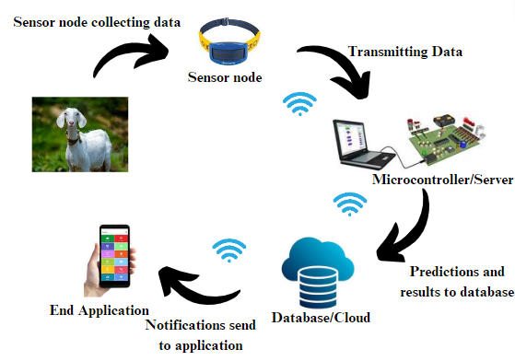

Figure 1.1 System Overview diagram of goat health monitoring system

# Literature Review:

The global trend of goat farming is increasing rapidly in developing countries due to the low input cost and the adaptability of goats to various climates. Goats Farming is increasing for multiples purposes including meat, milk and fibre fulfilling the demands of the different markets. This growth is increasing due to the increase in population and rising demand for protein sources in developing countries [11]. With increasing world papulation resulting in an increase in the demand for food and affecting farming practices becoming more significant. Sustainable and efficient methods are important in goat health farming to optimize the use of resources, improve productivity and minimize the environmental impacts. Improved breeding methods, integrated pest management, and rotational grazing are some of the practices that are becoming more popular [12].

Precision agriculture mode shifts farming methods through the advent of technology in agriculture. Farmers can monitor and farm more precisely the help of technologies like IOT (Internet of things) & data analysis. Technology is used for various purposes, including health checking, feeding and so on in goat farming. The concept of a digital twin, or digital replica of a physical system is developing as a creation of digital technology in many industries such as agriculture [13].

If applied to goat farming, the digital twin system for health monitoring could give farmers a more holistic picture of the health of each goat, as well as its behaviour and interactions with the environment. The information in real time can be analysed by this system and the system can predict the health issues and generate the alert which can lead to much efficient production and productivity of the farm. IOT and related devices integrate with the digital twin to do the data capturing which collect relevant insight and the software does the remaining analysis based on the framework within a fully workflow - oriented software. Benefits of using a digital twin-based system include disease detection which is faster and more efficient in earlier stages, better breeding techniques, better animal welfare etc. It can provide relevant environmental information and resource optimization - in accordance with the increasing world-wide drive towards sustainable agriculture - as well.

That is a significant progress in the transformation of the traditional goat farming towards the modernisation using digital twin enhanced health monitoring which is one of the subsets of a smart health monitoring system. Traditional approaches, which are highly focused on manual and visual observations, rest upon the knowledge and skills of farmers. This is not only important but often a matter of good but still subjective human eye and therefore limited observation. Core elements of the system are record-keeping, visual assessment, and daily health observations. While helpful, this is intrinsically reactive and often leads to catching health problems too late [14].

In a broader perspective, this is a good approach to the health management of livestock with the advent of digital twin-based technology in goat farming which is more effective, accurate and data-driven to use the IoT. Each goat gets a virtual model through digital technology and uses the real-time data from all the sensors you have in your IoT collection to make that happen. Sensors track aspects of basic physiology like temperature, heart rate, and movement, and these data are collected and transmitted 24/7. Traditional methods do not even come close in terms of the precision and extent of information collected. But simply storing data is only the beginning to this IoT-centric evolution, automation should involve the whole project in the final analysis. These data are processed by advanced algorithms which can find anomalies long before they are visible, possibly indicating heath issues. With this high tech, advanced system, the efficacy is apparent, as well as the accuracy. For the beginning, real-time monitoring and predictive analytics greatly improve early diagnosis of disease, an important feature for the proactive breeding of goat health. If we can detect at early stages and give intervention in time, the illness will be not worse and get much better recovery. The system is also known for its efficiency. It reduces human labour because as you may know data collection and analysis is labour intensive by applying traditional methods and this precious time can be used in other chain of agriculture. These solutions on the other hand are the equivalent of taking a scalpel instead of a hammer to ensure precision where traditional methods just take a blunt force to subset of the problem statements. By this way of tracking in real time and its data driven insights comes a more precise and reliable health assessment fewer chances of human error and oversight. Besides, the system's capability to synthesize and analyse various data types ranging from physiological signals to environmental factors provides an all-around picture into the health and well-being of each goat, a challenging task for one person.

The concept of real-time monitoring and historical data analysis integration has changed how animal health management is affected leading to the sustaining the health and improvement of livestock. Nowhere is this transformation more apparent than on the farm - in the context of the goat, where sophisticated technical systems monitor and analyse data in an effort to optimise health. Real-time monitoring could utilize several sensors and Internet of Things (IoT) devices to continuously measure different physiological and behavioural aspects of goats using body temperature, heart rate, respiration rate and movement patterns. The data are then sent to a central system, analysed to find sudden health problems or changes [15]. Real-time data is accompanied by data analysis which is an essential method historically used to point out the trends and patterns concerned with the long-term health situation of the goat. Farmers and veterinarians might map these data to include historical patterns of seasonality specific to disease types, genetic health signatures, or anatomical consequences from alignment with management practices on the farm. Like goats always eat during a particular time of year indicating that the feed or medication system may need to be altered, or this may be showing that the animal needs better control over its parasitic system, which can lead to weight loss at the same time every season. One of the main benefits of this synergy of real-time monitoring with historical data analysis is detect and avoid outbreak fast. AI and machine learning algorithm based predictive analytics can make use of the large, collected data, analyse it and predict potential health risks, provided health data warehouses adhere to rigorous data governance and security standards [16].

This advance approach can effectively prevent the onset of diseases and improve the overall health of the herd of goats, and farm productivity. The adoption of digital twin is advantageous to include better decision making and management practices for goat health monitoring system. For example, the information drawn from data-driven insights can help in making breeding decisions, planning nutrition and gaining an idea of the herd of goat activities generally. The integration of real-time monitoring and historical data analysis remains a vital element in the modern scenario of animal health management, and specifically in the case of livestock health optimization. This example of the use of such technologies in goat production illustrates the potential for a new approach to disease management which could become proactive and well-informed. With real-time monitoring (possible through for instance Internet of Things (IoT) devices), health indicators can now be tracked on a continuous basis in goats. Sensors are used to collect these indices, they can range from physiological parameters such as body temperature, heart rate to behavioural data like movement and feeding patterns and transmit it to a centralized analysis system. This can handle the information and give instant responses and alarms of the physical indicators to farmers and vets.

One good example of something like this would be a project that initiates wearable health monitoring for goats. Like a wearable fitness-tracker in humans, these devices continuously monitor an animal's vital signs and behaviours and provide real-time information on an animal's health status. When the system senses deviations from usual patterns, such as an unexplained increase in temperature or less movement, it instantly alerts the caretaker. This real-time notification is critical to early intervention, often the difference between a small problem and a major health problem [17].

Real-time analysis of historical data gives us important information on animal health by allowing us to detect patterns and trends that are not visible to the naked eye in the short term. Doing things like analysing historical data could easily help identify seasonal health issues, monitor the progression of a certain diet over time, etc. Analysing data in this type of way can be priceless when it comes to making choices concerning herd management, like changing feeding practices, or adjusting the environmental conditions to overall best health. The combination of real-time tracking with historical data interpretation is evidenced in predictive analystics. Their job is to analyze the corpus of data they have built up over the years and predict health problems before they become apparent through machine learning algorithms, which today can very well help establish health problems at an early stage. This ability to predict long before any symptoms are manifested represents a huge advance over conventional health management which tends to work only as a response to health problems after they have already materialized in the livestock population. In addition, the real-time and historical data integration for livestock management further improves how managers make decisions. Armed with the information, farmers can take better decisions in breeding, nutrition, as well as general health care practices [18]. This data-driven process looks after the well-being of the animals as well as the productivity and sustainability of the livestock-farming operation. With the ever-changing landscape of animal health, and the advancements in technology, age every goat monitoring system has materialized, each using different techniques and ways to better every goat herd mortality to suit the needs and needs of the producer. This is as simple as a wearable device through an integrated platform using IoT sensors, GPS tracking, advanced data analytics. This review critically evaluates this system in terms of various perspectives and efficiencies in detection and management of goat well-being [19].

The first class of approach uses sensor node devices - such as the same kinds of fitness trackers humans wear - that are attached to the goats. Wearable devices get constant streams of heart rate, body temperature and levels of activity. These devices will keep monitoring with the help of some of the data they collected, which is transmitted to an on-board central processing unit that will review the data for anomalous data or any signs of distress. Although these systems allow monitoring health condition of the animals in real-time, the effectiveness may be hampered depending on the durability and the operating battery life of the on-body sensor node, especially with being exposed to the typical rough farming environments. A stationary monitoring approach include fixed sensors placed around the live of the goats that measures information. The park has sensors that monitor things like temperature, humidity and goat behaviours. Inclusion of environmental data offers a wider perspective on variables leading to goat disease. Yet these systems are stationary which can restrict their ability to closely monitor the health of individual animals and thus the health data may contain gaps. Advanced systems integrate wearable with environmental sensors to truly enable health monitoring. Health monitoring systems not only monitor the data points but also analyze the group animal behaviour and environmental factors, all give a divided view of the herd health and behaving. The combined data sources make the health predictions more accurate. However, these sophisticated and often high-cost systems are not always adapted to the financial or operational constraints of small-scale farmers[15].

While monitoring a herd, most systems only take telemetry approach using temperature and movement sensor, but there are other systems using GPS tracking to how the goats are moving and grazing. It is especially useful with large herds and on extensive farming systems when goats graze hundreds of acres. It also uses GPS tracking to ensure the safety of the animals and to gain insights into their grazing behaviours. But a GPS-based system is only as strong as its satellite power: it can be easily compromised in remote or rugged terrains only reachable by satellite [20]. Integrating these data into advanced analytics and machine learning algorithms will use the versatility of these partial-to-missed goat health monitoring systems to a new stage. They also help in anticipation of a health problem before they manifest itself enough to need immediate attention. Nonetheless, the accuracy of these predictions is given by the quality and quantity of the observed data, and this can change from system to system.

Q-Fever in goats is a common clinical sign that can be triggered by anything from infectious diseases to stress of the environment. Although these health troubles are not new in the agricultural sector, they here to stay so monitoring at a vital level is essential, especially when it comes to goat farming which constitutes a major part of agriculture. Develop a new method of health monitoring for livestock area on health monitoring of livestock with digital twin technology. In this review we studied the pathology, symptoms of Q-Fever in goats along with a brief account of the economic loss due to the disease to stress the importance of advanced level monitoring systems such as digital twin technology. Q-Fever in goats is often accompanied by a high body temperature which can be indicative of several causes from infection (i.e. Peste des Petits Ruminants) and inflammatory diseases to toxin exposure. Lethargy, poor appetite (anorexia), dehydration, and/or coughing, are frequent presenting clinical signs of coxiellosis [21].

In particular, in regions where there is a core business of goat farming, the economic impact of Q-Fever is very important. Decreases appetite, reduces milk production and slows growth inevitably resulting in productivity loss. And in the worst cases, higher death rates. This includes vet care, medication and, in some instances, quarantine to properly handle the health care and spread of any infectious diseases [22].

Haemorrhagic Septicemia associated with high mortality (100% within 24-36 hours post infection) is mainly due to serotypes B and E of Pasteurella multocida. This acute disease is accompanied by sudden fever, salivating, respiratory distress, and heat death. Studies suggested that they might be due to stress and a change in environmental conditions including coexisting infection leading to immune suppression within the goats. Outbreaks of RTD are best controlled by preventative measures, vaccination and biosecurity are important. The need for continued investigation of vaccine efficacy and genetic predisposition to disease in goats is supported by the literature, to establish more information supporting appropriate management [1].

Haemorrhagic Septicemia results in severe economic losses in goats, particularly in villages, where goat rearing is an integral part of economic sustenance of many families. HS has a fast onset, high mortality and stock numbers can be severely reduced affecting meat and milk production. Culling affected animals is a common and extensive control measure adapted during the outbreak of disease and appropriately so, may also mount to the economic burden. Besides, an outbreak can result in trade embargoes and exclusion from markets, thereby increasing the economic impacts. One study suggests that a typical outbreak can decrease annual income from a farm up to 30%, emphasising the economic importance of successful HS management strategies.

Contagious Caprine Pleuropneumonia (CCPP), commonly referred to as Pleuropneumonia, is a severe infectious disease affecting goats, and has significant economic consequences, particularly where goats represent an important asset in the female farming sector. H The causative agent is Mycoplasma capricolum subsp. capripneumoniae (Mccp), a bacterium known for its high contagion potential highly advanced monitoring technologies, such as digital twin systems, can be integrated to vastly improve the management and containment of the affliction. Pleuropneumonia in goats characteristically involves both the lungs and the pleural cavity. It attacks the respiratory system from the get-go, causing a severe pneumonia. Transmission is rapid within goat populations via inhalation of aerosol or direct contact, and contamination in feed and water sources. Goats with the disease usually rapidly develop severe respiratory distress that can result in high rates of death if not promptly and effectively treated. The clinical findings are severe coughing and breathing troubles, high body temperatures with toxaemia in combination with symptoms of general malaise, initially serous than purulent nasal discharge, appetite loss, and associated weight loss, and in severe cases rapid significant deterioration of the general condition including deaths [24]. Pleuropneumonia causes economic damage on multiple levels. Such high death rates can cause herds to be dramatically reduced. The sick animals become less productive, which will impact on milk production and growth rates respectively. Financial pressure mounts due to vet's fees, expensive medications, and in the event of severe outbreaks, infected herds must be culled. Furthermore, the trade restrictions enforceable in the affected areas can put a strain on not only the affected local economy but also the national economy(data). This financial burden is felt almost more so in low-income countries where goat farming is the foundation of the economy. Here, the consequences for farmers, and the communities they live in, if the disease started to spread would be severe. Thus, to remain profitable and sustainable goat farming practices in these regions have no choice but to adopt more advanced disease monitoring and disease management systems such as digital twin technology.

This paper introduces the digital twin-based system setup for goat health monitoring to overcome the problems with the existing management practices for livestock health and take advantage of the latest advancements of technology. It combines real-time monitoring with data analytics to deliver an end-to-end health management solution. The digital twin-based system - which features a network of IoT sensors strapped to each goat - is an improvement when compared to traditional systems that rely on manual observation and data collection intervals [25]. These sensors are constantly measuring key parameters such as body temperature, heart rate, and motion. That live data is then passed to a digital twin - a computer-generated copy of every goat - so their behaviour can be studied closely, in real time. Real-time monitoring: One of the most important things about this system is real-time monitoring which is obviously better than some health checks running every few minutes that are used in other conventional systems. It facilitates early anomaly warning when individuals might be developing a health issue, and even predicts a problem that didn't yet happen to any patient, encouraging early intervention. This is especially important in the cases of Haemorrhagic Septicemia (HS), High Fever and Pleuropneumonia, where early detection can significantly decrease spread and impact of the disease. Predictive analytics is another breakthrough. Combining historical data with real-time data can help predict upcoming problems in a healthcare system even before it occurs. Machine learning algorithms within Dataset reinforce this predictive capability by developing understanding of patterns within the data, a feature pretty much non-existent in existing systems. There are many ways in which an analytics system can enable healthcare professionals with predictive capabilities - thereby leading to proactive healthcare management and containment of disease spread, and in turn improving overall public health. Digital driven systems also overcome scalability issues which are yet another shortcoming in conventional systems. An increased focus on software will lead to more visibility without direct increases in labour or resources. Reliant (2014) argued that scalability is imperative for more extensive health care systems and can be embedded for improved management as well. And, from an economic standpoint, this system is poised to lower costs of managing disease while increasing the productivity capacity of the livestock. Early detection and management of diseases leads to a reduction in the incidences of diseases, consequently decreasing the number of expensive healthcare managements and decreases the productivity reduction in livestock, hence reducing the economic losses. The system will also deliver data-driven insights about population health, nutrition, and general livestock management practices, which in turn could contribute to an improved economic performance.

The different sensors including accelerometer, temperature and humidity, heartbeat and pulse oximeter and gas sensors are strategically located near the ear of the goat and arranged in a specially designed node for the goat health monitoring system based on digital twin innovative techniques and providing an important breakthrough in animal health management in the livestock industry. This setup combines the best of each sensor type and allows for varied health monitoring capabilities for goats. Sensor Placed on close to the ear is important, as this is a part of the body that makes the data more accurate and does not cause discomfort and / or interfere with the animal's entire behaviour. Important component of goat collar is the accelerometer sensor at node which is being used to monitor the physical activity and behaviour patterns of goats. The band helps to detect movements that will give helpful information related to the animal's activity providing insights to the overall health & wellness of the pet. Gait abnormalities could thus serve as an early signpost for issues like lameness or lethargy.

Temperature and humidity conditions are one of the most important environmental variables influencing on goats. These sensors also supply data about temperature and humidity in the surrounding area for animals’ well-being and heat and well brier am maintained. Sudden changes in these parameters are indicative of adverse conditions which can cause stress or even disease in the goat.

The ear-mounted heartbeat and pulse oximeter sensor performs continuous monitoring of vital cardiovascular metrics. The sensor measures the blood oxygen level in real time, this can reflect the physical condition of the human body through the heart rate and blood oxygen level and the body's self- respiratory function. All these parameters are important to monitor to identify a problem early whether it be pneumonia or systemic infections, both conditions are not unusual in goats.

The other innovation is the gas sensor in the node for the monitoring of the respiratory health of goats. This sensor detects the presence and level of a few different kinds of gases in the goats' environment which in some circumstance may indicate poor air quality or harmful substances present. This monitoring is essential in avoiding respiratory diseases that are a problem in close packed livestock settings.

As a design choice, these sensors are strategically placed near the goat's ear. This location enables accurate physiological data between the major vascular structures used for heart rate and blood oxygen levels while assuring it is relatively non-invasive on the animal. Importantly, the node design is engineered to be lightweight, small and comfortable for the goat - such that it does not interfere with normal behaviour or mitigation and does not induce any distress within the goat.

Goat welfare monitoring systems are an important step in animal monitoring systems that consider not only animal welfare but also farm productivity. While a feat of technological innovation, the digital twin implementations modern systems deliver make this archaic two-dimensional approach to full lifecycle management seem unapproachably primitive. These superior monitoring systems were also the best and, without a doubt, are of great value in detecting diseases soon, thereby making it easier to take decisions and controlling the goat. This results in healthier animals, less losses due to illness and increased productivity in farm management. The elaborate incorporation of IoT sensors, with the addition of high-level analytics and machine learning algorithms to them has proven to be the game changer in making these systems accurate in monitoring and predictive parameters at levels unheard of in the earlier days.

Looking towards the future, the domain of goat’s health care monitoring is destined to technological further advancements. Among the hopeful examples might be the addition of AI-fuelled diagnostic tools that can use information from health monitoring systems to allow for diagnosing with increased precision and treatment recommendations. This development would go a long way to improving farmers and veterinarians’ capacity to respond quickly and effectively to health problems. One other possibility is the adding of genomic data to health-status tracking systems These systems embody precision medicine approaches which could enable the animal to develop better strategies for health heredity, so that each and every goat can have personalized care based on its genetic endowment. Moreover, the oncoming proliferation of cloud computing and big data analytics in livestock management is expected to help derive far more intelligent conclusions regarding herd health. Larger spatial scale allows for the recognition of patterns and trends not recognizable before, which improves the ability to make predictive models and even better management decisions from those models.

Table 2.1 Literature review summary

|  |  |  |  |
| --- | --- | --- | --- |
| **References** | **Study Focus** | **Techniques Used** | **Key Results** |
| [14] | Traditional Practices in Livestock | Rapid rural appraisal, interviews, field visits | Identified top five traditional practices: categorized farmer usage levels as low, medium, and high |
| [15] | IoT and ML for Goat Welfare | On-farm video, environmental monitoring, anomaly detection | System captured accurate data, validated the system's reliability for precision livestock farming |
| [16] | Goat Health and Welfare in Netherlands | Data from routine censuses | Highlighted trends in goat population, mortality rates, and provided insights for health surveillance |
| [18] | Machine Learning in Animal Agriculture | Review on data mining and machine learning applications | Emphasized the role of technology in enhancing efficiency and accuracy in data analysis |
| [19] | Drone Camera Tracking of Goats | Aerial imagery using drones, thresholding, supervised classification | Demonstrated high sensitivity and applicability for monitoring animal behaviour in outdoor settings |
| [22] | Q Fever Control Strategies | Modelling study combining stochastic and economic evaluation models | Found preventive vaccination as the most cost-effective control strategy for Q fever in dairy goat herds |

# Proposed Methodology

In modern agriculture, the integration of advanced technologies has revolutionized traditional farming practices, aiming to enhance productivity, sustainability, and animal welfare. One such innovative approach is the implementation of digital twin technology in livestock management, exemplified by the development of a digital twin-based goat health monitoring system. This methodology seeks to harness the power of digital twins – virtual replicas of physical assets or processes – to monitor and optimize the health of goats in farming environments.

The method is initiated through the realisation of health monitoring in livestock farming, especially in goats, where animals cannot speak to humans and work on these farms influences their well-being within the herd regarding its productivity. Farmers and herders have in the past traditionally depended on human observation to monitor the health of their livestock but would only seek veterinarian intervention when necessary. Nevertheless, these approaches are predominantly limited due to their reactive approach, manual nature and high probability of human mistake. With the proposed digital twin-based approach, on the other hand, a proactive and data-driven solution is developd which ensures that the system can be monitored on an uninterrupted basis with any impairments to its health identified in advance leading to an informed decision-making process.

Key to the methodology was a background of sensors placed in the goat yard recording environmental and individual vital statistics from grazing goats in real time. The data collected by these sensors (temperature, humidity, movement and heart rate-like) makes it possible to determine what are the conditions and physiological parameters of every goat. This data is then transferred to a central processing unit where it is converted and evaluated through Random Forest using a digital twin model.

The digital twin model acts as a virtual stabilisation of the health of each goat and uses sensor data to mimic the physiological state of the goat live on time. Using machine learning, statistical analysis, and pattern recognition the model can see abnormalities or anomalies in normal behaviour - be it early signs of health disorders - possibilities for future risk to the welfare of goats. Such a proactive strategy helps farmers and herders to respond promptly either by modifying the feed or environmental conditions or through veterinary intervention to alleviate health disorders and improve goat husbandry practices.

Moreover, the methodology emphasizes the importance of data storage, communication, and user interface components to ensure the effectiveness and usability of the monitoring system. Historical sensor data is stored for analysis and model refinement, while real-time communication enables remote monitoring and integration with external systems. A user-friendly interface, accessible through mobile applications, provides stakeholders with actionable insights, alerts, and decision support tools to facilitate informed decision-making and proactive management of goat health.

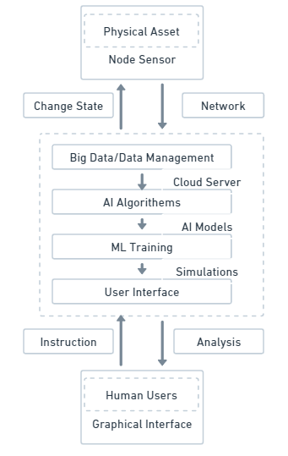

Figure 3.1 Block Diagram of Digital Twin

## System Overview

Medical field will be taken to new levels with micro processing chips. The design of a good monitoring system will have to satisfy several different requirements, power consumption, room efficiency and security, among which the first two must be the most important factors. However, this required costs to be made on customs and off-the-shelf microchips to attain these factors. Most monitoring systems typically leverage off-the-shelf chips for communication, sensing, and in some cases, computing. But the real value comes when connecting the chip and developing it as an all-in-one, single chip solution made for a single SIP -- ready to be controlled by software in ways never seen on a silicon.

Therefore, by using all these techniques and solutions, we have designed a system for the registration of the goat and real-time monitoring. The body area sensor network for wireless is projected to collect the different physiological parameters to make a diagnosis and for alert messages. Table 2 presents the sensors to sense these types of parameters. The system will consist of different sensors mounted on the wearable device, and it will be in the goat attached to specific appropriate locations. Each goat is assigned a specific ID that will allow us to identify the monitored goat. A communication modem is used to make such values radios to microcontroller, which is connected to sensor nodes. In this case since there are multiple data-gathering sensor nodes sending their data to a single microcontroller, there will be the possibility of data collision so different sets of protocols will be employed to transmit the data without any loss. Each goat has believed it a digital twin and get values in real time, And the machine learning-based algorithms help us to diagnose and to find diseases on some parameters in biology, in this case, a model will be trained for it. Data will then be stored with the help of a cloud-based database, connected to a user-end application.

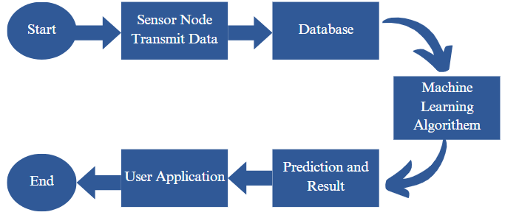

Figure 3.2 Block diagram

## Hardware Details:

Table 3.1 Hardware details

|  |  |  |
| --- | --- | --- |
| **Non-Invasive Sensors** | **Sensor Model** | **Parameters Detected** |
| Heartbeat Sensor | MAX30102 Pulse Oximeter | Pulse Detection and Heartrate |
| Temperature Sensor | DS1820 | Body Temperature |
| Accelerometer | ADXL345 | Grazing |
| Gas Sensor | MQ-135 | Detection of smoke, Vapours, CO2, and other harmful gases |
| Temperature and humidity | DHT22 | Temperature and humidity |
| Temperature | DS18B20 | Goat Temperature |

### ESP32:

The ESP32 family includes the ESP32-Wroom-DA microcontroller, which is the one in use in this project and featuring benefits like ease of use and processing power give it an incredible ease of use and processing power. After spending hours of efforts, I found that which is "Unlike traditional Arduino Uno boards, you do not need to get a shield to add WiFi to an Arduino board but simple get a board with WiFi feature on chip". Thus, removing the requirement of additional hardware assembly makes Development simpler running File Chooser.

The ESP32-Wroom-DA board has some interesting specifications, such as a powerful single-core processor based on a 32-bit Dual-core Ten silica LX6 architecture clocked at up to 240 MHz. It run at an operation voltage of 3.3V and provides enough room for extensive storage thanks to the 4MB Flash Memory. These features make the ESP32-Wroom-DA an excellent choice for applications host or Wi-Fi function offload for other application processors.

The ESP32 variant on the chip or model - the ESP32-Wroom-DA microcontroller, boosts up the power of an ESP32 even more. ESP32 can work on its own or attach with other Controller for data processing or actuator control, this makes it very flexible platform to develop IoT-based systems. The software seamlessly integrates with different kinds of sensors and peripherals, which makes it quite easy to sense and transmit data to centralize servers for in-depth analysis and processing.

The ESP32-Wroom-DA microcontroller in combination with ESP32 provides a power-efficient, scalable chipset for IoT applications capable of high performance, ease of use and the compatibility to connect seamlessly to a large variety of devices and sensors.

Table 3.2 Characteristics of ESP32

|  |  |
| --- | --- |
| **Parameter** | **Specification** |
| Operating Voltage | 2.2V - 3.6V |
| CPU | Dual-core Ten silica LX6, up to 240 MHz |
| Connectivity | Wi-Fi, Bluetooth, BLE |
| GPIO Pins | Up to 34 |
| Analog-to-Digital Converter (ADC) | 12-bit resolution |
| Parameter | Specification |

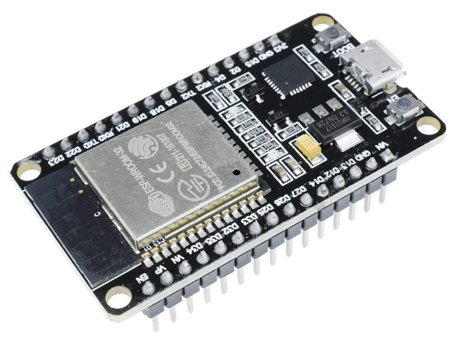

Figure 3.3 ESP32

### MQ135 Gas Sensor:

The system consists of the MQ135 gas sensor, which is the important component in the system where it will be used to maintain the air quality in the environment of the goat housing. The MQ135 sensor is designed to detect gases like ammonia, methane, carbon dioxide and benzene amongst others and this makes it very important in identifying potential health hazards and environmental stressors that affect goats.

The presence of harmful and toxic gases and pollutants, which are hazardous to the goat, can be recognised by using MQ135 sensor, which continuously keeps the monitoring of the gas levels. Because of its high sensitivity and precision, environmental anomalies (e.g., increased CO2, humidity, ammonia levels and temperature) can be identified in their early stages so that farm use can take an early response and so the goats health and well-being can always be kept on optimal condition.

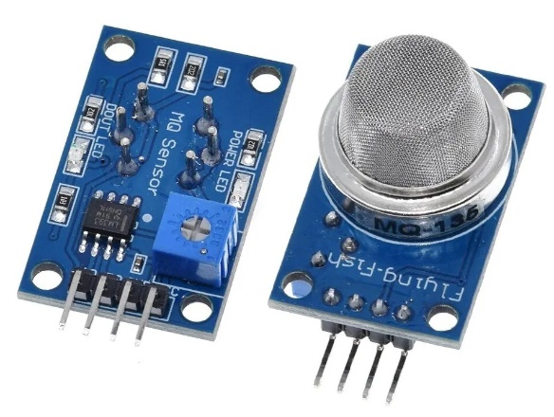

Figure 3.4 MQ-135

### DHT22 Temperature and Humidity Sensor:

DHT22 is a digital temperature and humidity sensor system, this sensor is embedded as part of the system in monitoring environmental conditions in goat housing. Such a sensor can be used to measure the temperature and humidity of the soil and is important to keep the goats at the right level.

Steadily observing temperature and humidity, the DHT22 sensor ensures that goats will not succumb to heat stress, dehydration, and other environmental issues that threaten goats. This high precision and reliability guarantee an early warning system, so that farm managers can regulate the ventilation, heating, or refrigeration systems now they are needed to optimise both goats' welfare and productivity.

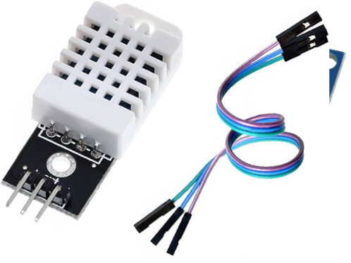

Figure 3.5 DHT22

Table 3.3 Characteristics of DHT22

|  |  |
| --- | --- |
| **Parameter** | **Specification** |
| Operating voltage | 3.3V - 6V |
| Temperature range | -40°C to 125°C |
| Humidity range | 0% to 100% RH |
| Accuracy | ±0.5°C (Temperature), ±2% RH (Humidity) |
| Signal Output | Digital (Single-wire, Two-way communication) |

### ADXL345 Accelerometer:

The three-axis ADXL345 accelerometer, is used to measure acceleration forces, which helps in monitoring the movement and behaviour of the goat. The sensor, built into the system, helps to give an indication as to the activity levels and behaviour of the goats - an invaluable tool for farm managers to measure their health and welfare.

It can sense different movements & postures and thus used to detect when a goat is not moving or moving in an unusual way which might indicate distress/or injury/ or abnormal behaviours. Real-time monitoring ensures that help is at hand and reduces the overall risk of losing goats in the hardware facility.

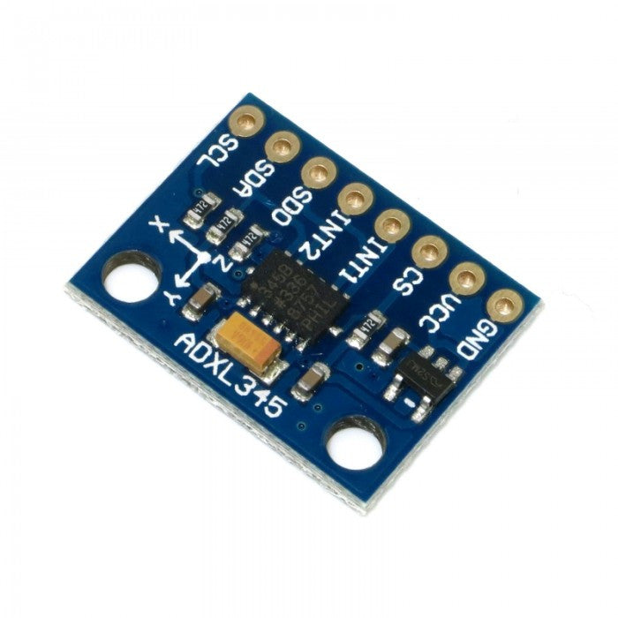

Figure 3.6 ADXL345

Table 3.4 Characteristics of ADXL345

|  |  |
| --- | --- |
| **Parameter** | **Specification** |
| Operating Voltage | 2.0V - 3.6V |
| Measurement Range | ±2g, ±4g, ±8g, ±16g |
| Resolution | Up to 13-bit |
| Output Data Rate (ODR) | Adjustable, up to 3200 Hz |
| Communication Interface | I2C, SPI |
| Low Power Consumption | 23 μA in measurement mode, 0.1 μA in standby mode |

### MAX30102 Pulse Oximeter and Heart-Rate Monitor:

Sensor-Based Health Monitoring: The MAX30102 sensor module which also includes a pulse oximeter and heart-rate monitor makes it possible to monitor cardiovascular health in a non-invasive way for our goats. The component measure heart rate and oxygen saturation levels that are major aspect need for the early evaluation of such type of Cardiovascular Abnormalities or irregularities in case of goats.

The MAX30102 sensor tracks essential parameters including heart rate and oxygen levels which allows goat owners to estimate the general health status of their goats, in other words to manage medical care proactively and make strategic medical interventions. Utilising a patented algorithm, the robust and precise measurements can inform farm managers when cardiovascular health of the goats may be compromised, facilitating early treatment and preventive measures.

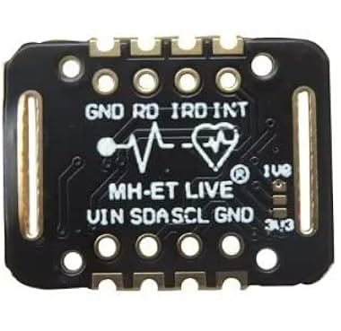

Figure 3.7 MAX30102

Table 3.5 Characteristics of MAX30102

|  |  |
| --- | --- |
| **Parameter** | **Specification** |
| Operating Voltage | 1.8V - 3.3V |
| LED Wavelengths | Red: 660nm, Infrared: 880nm |
| Sampling Rate | Adjustable, up to 3200 samples per second |
| Communication Interface | I2C |
| Power Consumption | Less than 1mW |

### DS18B20 Sensor:

Goats Body Temperature Measurement using DS18B20 temperature sensor. For goats, the normal body temperature should be within 37.8°C to 39.2°C, and departures from this normal range may be indicative of an underlying health issue and should be treated.

So, in this way the DS18B20 sensor offer a perfect stable, and a precision temperature reading for our specific case. The hardware block provides up to 9- to 12-bit temperature resolution, which can be adjusted to trade between resolution and number of measurements allowed. The sensor has a wide measurement range from -55°C to +125°C, which means it can effectively capture the changes caused by temperature in a variety of environments.

The one of the DS18B20 sensors benefits are his individual 1-Wire interface which makes implementing communication with it easier and it requires only 1 port pin for data line. This function is useful in our digital twin-based system where we can have several sensors in different part of the goat farm.

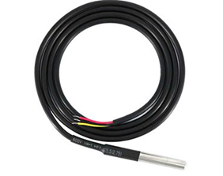

Figure 3.8 DS18B20

Table 3.6 Characteristics of DS18B20

|  |  |
| --- | --- |
| **Parameter** | **Specification** |
| Operating voltage | 3V - 5V |
| Temperature range | -55°C to +125°C |
| Temperature Accuracy | ±0.5°C (from -10°C to +85°C), ±2.0°C (outside range) |
| Resolution | 9 to 12 bits user-configurable |
| Signal Output | 1-Wire (single data line for communication) |

## Dataset Working:

The dataset collected using the ADXL345, MAX30102, MQ135, DHT22 and DS18B20 sensors and categorised the High Fever, Contagious Caprine Pleuropneumonia (CCPP,) and Haemorrhagic Septicemia (HS) diseases according to their symptoms. Furthermore, details given below:

### Data Collection:

**DHT22:** Collects temperature and humidity of the environment.

**MQ135:** Measures surrounding air quality, including the presence of different gases like ammonia, carbon dioxide, and other pollutants.

**ADXL345**: Measure monitors goat activity and movement of the goat.

**MAX30102**: Measures heart rate, and blood oxygen levels of the goat.

**DS18B20:** Measures body temperature of goat.

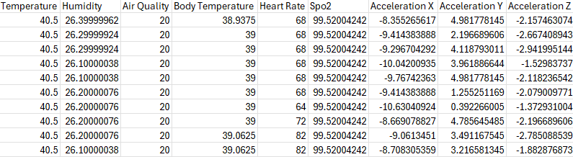

Figure 3.9 Dataset Collection

### Data Processing:

All data streamed from every sensor, is processed and analysed in real-time via the processing unit of the system.

The sensor data collected in the cloud is processed using an advanced algorithm (machine learning model) to interpret it and identify patterns that can predict the health status of the goat.

### Health Monitoring:

**High Fever Detection:** If the temperature given by the DS18B20 sensor goes beyond a threshold that might indicate variations leading to high fever it triggers a warning sign.

**CCPP Detection:** Contagious Respiratory Disease Use of MQ135, which is used to sense heating materials as ammonia and other similar respiratory irritants, where if many irritants were detected, and the sensor pushes detected abnormal breath patterns from MAX30102 this might be indicating a distressful respiratory pattern because of CCPP.

**SH Detection**: SH Detection: SH may lead to respiratory illness, respiratory failure with high fever. Here the body temperature and respiratory issue in the goats can be detect by the DS18B20 and MAX30102 sensor which is the symptom of SH.

Figure 3.10 Disease Prediction

### Alert Generation:

The system generates alerts for abnormal sensor readings potentially indicative of high fever, CCPP or SH. Farmers or herders can quickly view these alerts on their mobile application or web-based dashboard, informing them of the possible health problem.

### Data Logging and Analysis:

A history of all sensor data, alerts, and diagnostics is logged and stored for review.

An example where perhaps more of a direct relationship would occur is historical data analysis of not only the spread of diseases, the effectiveness of interventions but also for overall herd health trends over time.

### Feedback and Intervention:

Based on the analysis of sensor data and alerts, farmers, or veterinarians intervene timely taking correct actions such as putting infected animals under isolation, carrying out treatment protocols, or consulting with a veterinary specialist. They provide a score for what good looks like which can be used to enhance and drive improvement in health management.

The proposed system contributes to the proactive health monitoring and disease detection in goats through the integration of data from multiple sensors with advanced analytics, for achieving an optimized goat health raising and preventing strategy, enhancing welfare and productivity in goat farming operations.

## Software Details

### AWS cloud

Amazon Web Services (AWS) is a major cloud computing platform that has become the go-to solution for companies looking for scalable, global power and varied service offerings. AWS has a wide range of regional presence in more regions and Availability Zones, with very low latency, availability. Security is a top priority a variety of features such as IAM, Encryption and Compliance Certifications. With their pay-as-you-go pricing and cost control features, they allow users to minimize their spend. It Is developer friendly - lots of tools and resources, especially with AWS in general. For data analytics and machine learning it is outstanding, with services like Amazon Redshift and Amazon Sage Maker. The other major development: AWS enables a whole new set of businesses to innovate and to simplify (and reduce the cost of) many IT operations, all while leveraging the power of running infrastructure on someone else's computers.

### Aws IoT twin maker

AWS IoT Twin Maker - You can use AWS IoT Twin Maker to develop digital twins of physical systems, such as factories, buildings, and industrial equipment. Made from data derived from sensors, cameras and elsewhere, these digital twins allow you to monitor in real-time how your physical systems are performing. Another application of the tool - AWS IoT twin Maker - is to combine real-world data with existing 3D models to generate an accurate snapshot of your operations. In the long-term, the increased visibility lets you track performance of equipment and predict any issues in advance to maximize efficiency by tuning up process. In addition, AWS IoT Twin Maker makes it easy to interact with data at scale by integrating with many more AWS services and customizable connectors for external data sources. Thus, you can avoid moving data in and out if the requirement is just of converting data formats making it easily consumable by any application. In addition, AWS IoT Twin Maker takes friction out of the development process with a pre-built knowledge graph that in turn automatically links your data sources to the digital twins. This means that you can devote your attention to creating virtual replicas which allow for increased operational performance.

## Application of digital twin

In a digital twin assisted intelligent, goat health monitoring system implementation, the technology would presumably be used to produce a virtual replica or emulation of the physical goats and their surroundings. Some Potential Uses for Digital Twin Technology.

### Virtual Representation of Goats

The digital twin can be used to simulate a wide range of health parameters for goats, including body temperature, heart rate, activity levels, and more, and then provide real-time monitoring and analysis for those parameters.

### Health Monitoring and Predictive Analytics

Monitoring in Real Time: The digital twin will be able to monitor the health of goats with sensors which are attached on it and collecting data for analysis at 24/7 and store the last data.

In the following article, you will learn what data can digital twin collect to go along with benefits of predictive maintenance.

### Environmental Simulation

These digital twins may also simulate the living conditions in which the goats will be living and working, enabling nodes that monitor temperature, humidity, odour, air quality or other relevant factors to be included. It was same as evidence of environmental impacts on goats’ health.

### Precision Farming

A digital twin can help optimise Feeding schedule & Nutritional requirement for each goat based on its health and requirements.

### Decision Support System

The digital twin can set off alarms that prompt farmers or veterinarians to do on-farm interventions when physiological health markers deviate from normal. It may also suggest the best steps to be taken.

### Remote Monitoring and Control

Farmers can see the digital image of a twin and monitor the health of one's twin from anywhere. It is especially helpful for farmers who are not able to be on the farm all the time.

### Data Integration and Visualization

The data can be merged across various origins of the data like sensors, veterinary logs, historic data by the digital twin. This information is then made meaningful using visualization tools for better decision making.

In summary, the digital twin is expected to provide an integrated real-time, intelligent and interactive framework of Realtime and predictive analytics, and simulation for effective goat farming practices, detection of early health issues of goats or low breeding management.

## Integration of hardware and digital twin

### Sensor Integration

These goats are tracked by a variety of minute hardware sensors posed to collect real-time datum from them. And these sensors would be things like temperature sensors, heart rate monitors, GPS trackers, accelerometers and so on. These physical parameters, activities of the goats are sensed by these sensors.

### IoT Devices

Sensors are connected to a digital platform using Internet of Things (IoT) devices. They enable the exchange of data from the real world to the digital twin side. For example, the sensors could have attached to them a microcontroller, or a small computing device used for data aggregation and transmission.

### Communication Protocols

Some of the standardized communication protocols (MQTT/ Message Queuing Telemetry Transport or HTTP) can be leveraged for fault-free interaction between hardware devices and the digital twin. This makes transferring data from the sensors to the digital twin effective.

### Modelling the Physical System

The digital twin is a virtual representation of the literal goats and where they live. This means building a fully-fledged model that replicates as best as possible the traits, behaviours, and states of real goats. Based on the data which is received from the hardware sensors this model continuously updates.

### Real-time Data Integration

With the hardware sensors providing real-time data, digital twin is continuously updated to represent most recent actual condition of the physical system. They can be used to monitor the health and behaviour of goats in real time.

### Analytics and Decision Support

The data inside the digital twin can be analysed using advanced analytics and ML (machine learning) algorithms to find trends, patterns or detect anomalies or possible health issues. Based on this data processed by the digital twin, one could potentially carry out predictive analysis of health for the goats and prevent any calamities from happening pro-actively.

### Remote Monitoring and Control

Through the digital twin, users can keep up from a distance with goat health and behaviors. It also allows the introduction of control systems (e.g, adjusting environmental parameters or administering medication on the analysis of the digital twin).

### Historical Data Storage

The digital twin also provides historical information to enable trend analysis and long-term health assessment. As this data can be used for research purposes and using it, the system can get improved effectively and decision-making in such an environment will be rational.

### Dashboard and Visualization

This might have a UI, like a dashboard, that allows for more intuitive engagement with the digital twin. That interface can show real-time data, trends over time and even alerts when the goats are sick.

### Alerts and Notifications

From the results of its analysis in the digital twin, it becomes possible to generate warnings or alarms that facilitate an early warning for users of possible health problems.

## Wireless Body Area Network (WBAN)

The digital twin-based implementation of goat health monitoring system for prediction of Haemorrhagic Septicemia (HS), Q-Fever, and Contagious Caprine Pleuropneumonia diseases to tuned WBAN details can be as follows: A smart sensor node integrated with a gas sensor to detect acetone gas, temperature change sensing transistor for measuring body temperature, heartrate BPM measure and SPO2 value via modified LED + Photodiode based probe mechanism and accelerometer for abnormal movement detection will be mounted on each goat. The sensors that will be used in this case will be merged into the node equipment for each goat to guarantee reading of proper data. These sensor nodes will collect bio-physiological, body temperature, humid, heart rate, breathing rate, activity levels. These parameters will help in diagnosis to diseases like Haemorrhagic Septicemia (HS), Q-Fever and Contagious Caprine Pleuropneumonia. Communication modems are employed to communication the aggregated data with central microcontroller from the sensor nodes. The data will later be used by the machine learning algorithms to provide accurate diagnosis of diseases subject to the biological parameters. The parameters which have been diagnosed with labels such as disease presence or health will be saved in a cloud-based real-time database. This stored data will be useful for disease detection (Contagious Caprine pleuropneumonia, Haemorrhagic Septicemia (HS), etc,) high fever, or healthy status in goats. The system will constantly measure these physiological parameters to identify anomalies or early signs of illness. Analysis of sensor data will be conducted, and alerts and notifications will be generated to drive the timely intervention.

# Implementation

Digitalization has the potential to contribute largely towards the economy and provide countless job opportunities locally. A digital twin-based goat health monitoring system that signals potential health problems in goats in advance along with the health indicator and historical data, is waiting in the wings and is expected to change the conventions of livestock management. We will use a mix of design elements, clinical insights, and engineering techniques to develop such a system that may be used to accurately score any deterioration in goat health. This is a ground-breaking method that could play a significant role in alleviating the problem of hunger-especially in populations of high growth areas. We can keep millions of people alive per year by averting the risk of hunger through better livestock management for more reliable food supply. Every part of the system has been set up with this purposefully and our system is designed to make a positive impact on the sustainability of agriculture by providing farm owners with the guidance and alerts they need to efficiently keep their goats healthy and when necessary, avoid the impact from diseases far better than if left to their own devices. We can build digital twins based upon the data gathered from real-world goats, allowing us to examine the incredibly detailed and diverse this data is, and to simulate it to understand how a goat's health works. To get the desired output. This virtual model allows for use of more of a proactive approach to intervention strategies and decision-making for better health outcomes and increased livestock productivity. Our approach that involves integration of advanced technology with practical solutions will potentially revolutionize the field of agriculture through a digital twin-based system to monitor goat health.

## Wireless Body Area Network

Wireless body area networks (WBANs) are a particular type of sensor network using wireless sensor nodes on a person’s body to measure physiological parameters such as blood pressure, body temperature, heart rate, and blood sugar level, enabling a patient’s health to be monitored remotely [37]. For this system, the sensor node is deployed for each cattle. Each sensor node consists of a gas sensor, temperature sensor, and accelerometer which are responsible for detecting acetone gas, measuring body temperature, and detecting jaw movements, respectively. These nodes are carefully integrated with each goat’s wearable equipment to ensure each sensor is accurately measuring the required data.

A wireless body area sensor network is used to collect the different physiological parameters on which diagnosis and alerts will be conducted. Literature surveys led us to the conclusion that the several types of biological parameters that map to diseases are body temperature, humidity, heart rate, respiration, and fall detection [38]. Various sensors have been attached to the wearable device, a collar for goat. All goat gets its own node which will help us to identify the one being monitored. The Communication modem connected to sensor nodes helps us to transfer these values to a microcontroller. Algorithms based on machine learning help us to accurately diagnose and identify diseases on various biological parameters. The parameters and their label, whether it is affected by a disease or healthy, will be further stored on a cloud-based real-time database. These parameters will help us to identify diseases like ketosis, FMD, mastitis, high fever, or if it is healthy. Figure 10 presents the circuit diagram of how nodes are developd.

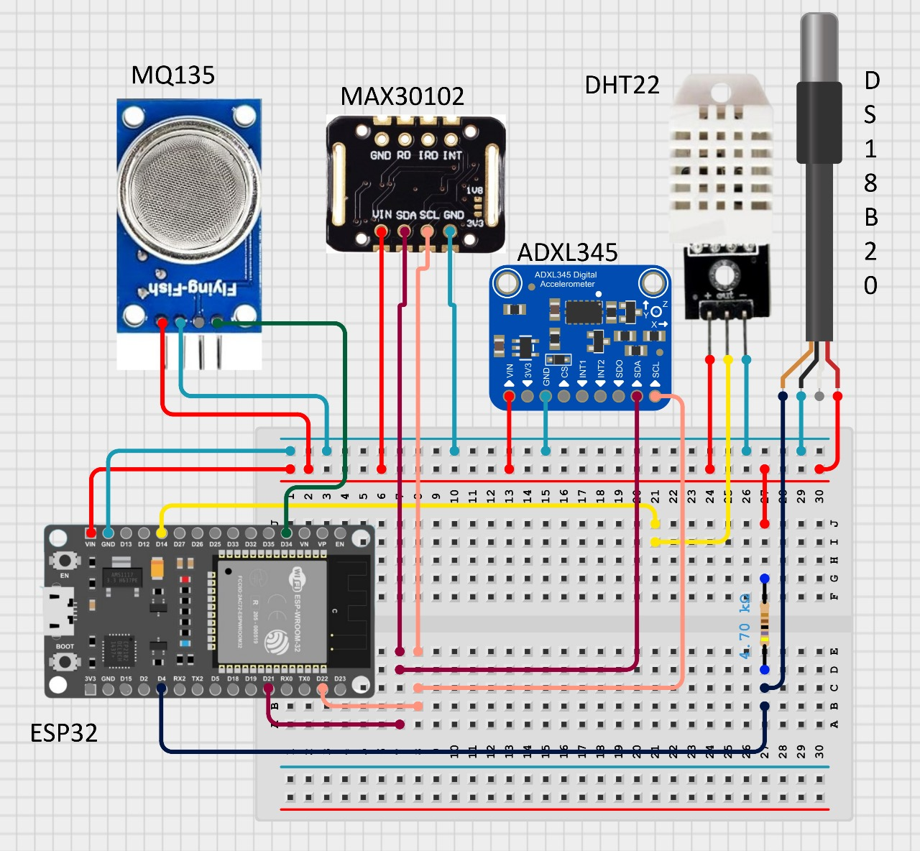

Figure 4.1 Circuit diagram

## Machine Learning Model

To train a model for each client, first, we need to check whether it is a classifier or regression. So, this type of problem is, in this case, a multi-class classification problem. It aims to detect three of the most common Haemorrhagic Septicaemia (HS), Q-Fever, and Contagious Caprine Pleuropneumonia diseases. Physiological parameters of goats obtained from sensor nodes - temperature, humidity, heart and respiratory rate, and activity levels This data will be transmitted wirelessly to a central microcontroller via communication modems. This data will need to be pre-processed to account for any noise, outliers, or missing values. We will perform some data normalization technique to make sure we scale all input features to the same scale. The most important feature selection algorithm will be employed to select the features that predict diseases This could reduce the dimensionality of the data, resulting in the efficiency of the machine learning model. Based on the characteristics of the data and accuracy requirements, a good choice will be made in machine learning algorithms.

Some popular algorithms for predictive modelling include Decision Tree, Random Forests, Gradient Boosting, Neural Network and Gaussian Naive Bayes. The selected algorithm will be trained on the pre-processed data using a supervised learning approach. The model will be trained to learn the relationships between the input features and the corresponding disease labels. This allows us to evaluate the trained model, using a held-out validation set, for its performance on disease prediction. The model will be evaluated using metrics like accuracy, precision score, recall score and F1- score.

This final model will deploy on the digital twin-based goat health monitoring system. This system will continuously record the physiological parameters of each goat and through predictive model trained predict the onset of disease. If the model predicts that the disease is present a, an alert will then help with timely intervention. The alert will contain details of the goat identification, the main disease under consideration and the recommended action. By employing the Random Forests Algorithm for machine learning in the digital twin-based goat health monitoring system, the system can effectively predict and prevent diseases like Foot-and-Mouth, Q-Fever, and Contagious Caprine Pleuropneumonia in goats through real-time monitoring and data-driven insights.

### Random Forest Classifier

A powerful and flexible ML algorithm, the Random Forest classifier, was employed in four feature spaces in our digital twin implementation for goat health monitoring. It is a type of ensemble learning method in which multiple decision trees are built and when making a prediction of a class (classification) of a new input, the mode of the class (i.e. having the majority votes) is selected. The output of Random Forest is the predictions of several tree-based classifiers, to obtain a value that has lower overfitting than that of an individual model. Our system, that diagnoses sensor diseases of goats, exploits these features, we select the Random Forest algorithm to be our classifier because it can handle the high-dimensionality and the noise in the dataset. Continuous attributes (temperature, accelerometer readings, acetone levels) are handled which are in fact available in the dataset itself. Training: Random Forest builds a few decision trees by choosing the dataset and variables randomly. Here, there is a tree in the forest for each bootstrap (bootstrapped) sample drawn from the training set.

When training each tree, random subsets of features are picked up, providing to model diversity and reducing the correlation among individual trees, thus increasing model performance. At each node of the tree, it splits on the best feature from this subset of features. On a new sample, each tree votes for a class, and the class that receives the most votes is the prediction of the model. Although Random Forest classifier is more robust, it is computationally expensive especially for many trees and deep tree structures. Still, it is performing well and can be parallelized well over many processors. The downside is, it can be a black box because the overall ensemble model is less interpretable compared to a single decision tree.

## Random Forest Classifier Working

### Training

Starting with a training dataset of sensor data X and goat health status class labels Y the classifier constructs multiple decision trees on the all the sensor data *x*. Every tree in the forest is trained on a random subset of the data (with replacement), and for each decision to split a node, a subset of features is randomly chosen to determine the best split. Split the training and testing is 70% and 30% respectively.

Bootstrap Sample: For every tree T in the forest, randomly sample both X and Y with replacement to form a bootstrap sample Bi. At each node finding F (randomly selected subset of features) and evaluating the splitting criterion on those features (e.g. Gini impurity/Information gain) to find the best split or not split at all. A tree is grown until a stopping criterion is met (e.g. maximum depth, minimum samples per leaf).

**Gini Impurity**

(4.1) shows 𝑝𝑖 is the probability of class *i* in the dataset D.

**Information Gain**

where Entropy(D) (4.2) shows is the entropy of dataset D, and D*v* ​ is the subset of D for which attribute 𝐴 has value v.

### Calculating Class Probabilities

For a fresh input features *x*, the classifier estimates the class probabilities by taking the average of predictions of all decision trees in the forest. Each tree gives a class vote and we model the posterior probability of each class from that vote.

**Probability Estimation**

(4.3) shows T is the total number of trees, and 𝑃𝑖 (𝑐 ∣ 𝑥) is the probability of class c predicted by the it trees.

### Prediction

The predicted class label of the new instance is decided by the class label with the most votes in all decision trees, revealing information of the health status of the goat (based on sensor observation).

**Majority Voting**

(4.4) shows *I* am the indicator function that returns 1 if 𝑇𝑖 (𝑥) equals class c, otherwise returns 0.

### Assumptions of Random Forest

Random Forest Although Random Forest does not assume independent features as in Naive Bayes, it assumes the ensemble of randomly chosen trees is capable to outperform the individual trees. The performance of the model is dependent on parameters such as — number of trees in the forest T, depth of each tree d etc.

**Error Reduction:**

### Benefits and Limitations

Random Forest - Accurate for large data sets with higher dimension. In addition, it is less oversensitive to complex relations between the data. But it is computationally expensive specially when we increase the complexity of the model by adding more trees or deeper trees. Further, due to ensemble nature, interpretation of ensemble models like this can be difficult. Random Forest is very efficient on a practical level, i.e. in goat health monitoring system based on digital twin approach, where it provides strong and stable results, despite that not so easy from mathematical analysis point of view.

## Mobile Application

Goat health prediction is done based on *the* collected parameters through the node. Anybody who owns a farm or herd of goats and has deployed our system can easily monitor their goats. A React Native mobile application is developed with the AWS backend. React Native is a powerful JavaScript framework for building mobile applications. It saves time and resources as it can develop mobile applications for both platforms, i.e., Android and iOS with the same code base. React Native also provides access to native APIs, allowing developers to access device-specific features.



Figure 4.2 Main Page

### Splash Screen

A splash screen is the first launching or booting of your mobile application, a sweet spot that displays some logo, name and image for your app on boarding Having a splash screen that features the app logo, background image or its branding element in 80 milliseconds will be early enough and can prevent loading with a blank white page for your React Native app. It is crucial for the app marketing purpose and leaves the first impression on users. The application developer can specify the duration for splash screen to stay visible, normally three seconds before it automatically redirects to the main part of the app, like login screen. It generates any pending background task like fetching data or authentication checks to complete.

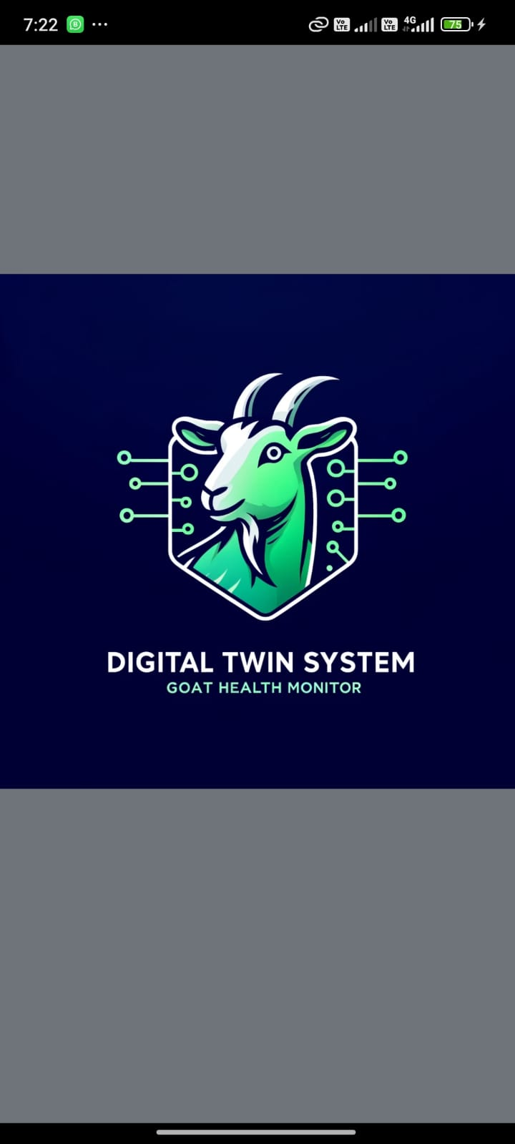

Figure 4.3 Splash Screen

## Login Page

Authentication in most cases is always a required step now on the login page developed with React Native and AWS. Amazon Web Services AWS provides an uber cool range of cloud services with some best-in-class authentication and data management tools and believe it or not you can easily incorporate them into your React Native application. To be able to develop a login page in react native with AWS, you need to follow these important steps. You first must develop an AWS account and set up the following services, AWS Cognito for Authentication, AWS Amplify for SDK integration, and 3.AWS DynamoDB for Databases. When AWS Cognito for auth has been set up, then let's develop the login page in React native app. This is a page and user should be able to enter their email and password on the form. It means this is a submit button and when we click on this button the authentication process should start. The authentication must be initiated by the React Native app hence it has to use the AWS Amplify SDK. The App Auth SDK gives a collection of functions and APIs for handling protocols like AWS Cognito allowing you to manage all aspects including user account creation, logging users in and gracefully handling error. On submitting login, the React Native app should call the AWS Amplify SDK function for authenticating that user.

Upon successful authentication the user should be directed to your app's protected content; If the authentication is unsuccessful, then a new page can be shown to the user and a suitable error message should be displayed. For a better user experience, customary features like introducing social login, password recovery, and multi-factor authentications can be added on the login page. This means that users can log in using their Google, Facebook, or Amazon account which all work out of the box seamlessly with AWS Cognito. At last, for the user account security, multi-factor authentication (MFA) could be used in the login page. MFA is a security feature that needs the user to enter two means of authentication to access his account e.g., password and one-time code which is sent on user phone or email. It has defined APIs and functionalities for MFA implementation that can be consumed in the app. AWS provides functions for MFA available that we can use in React Native applications.

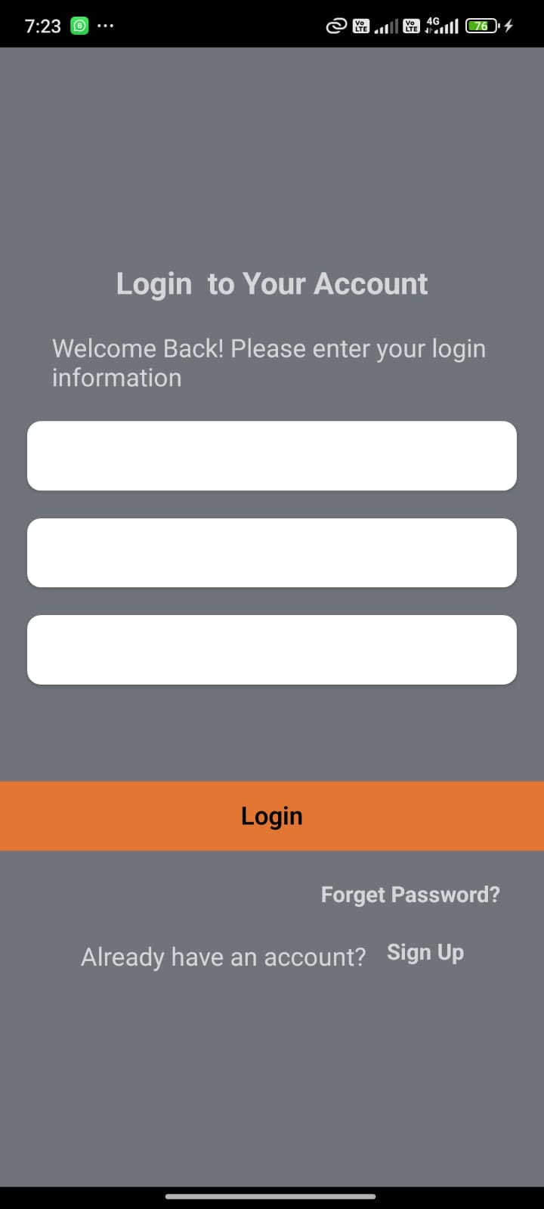

Figure 4.4 Login Page

## Signup Page

The Reason Users Can Develop Their First Account and Access Protected Content Inside the App - Signup Page in React Native w/ AWS English Amazon Web Services (AWS) provides developers with all the tools and services they need to build web and mobile applications on a secure, reliable scale. Build Signup Page in React Native with AWS - Authenticate Your App with AWS Cognito This would mean creating an AWS Cognito user pool, setting up authentication, and adding the required AWS Amplify SDK in a React Native app. Next, we can develop signup page with in the react native app after setup AWS Cognito. Checkout this Should have an email and password input box for the user to enter their Signup Information with a button to submit on Data Change of auth-loading. The user enters their sign- up information and the app use the AWS Amplify SDK to develop a new user. The user should pass to the protection content with app if their account is successfully sign-up Console read from the user again, without any modification performed to the signup information provided by the user when account creation would fail.

Using AWS Cognito error codes and messages is the way to handle all those signup errors at one place so that we can show some user-friendly error messages. E.g., if the user enters wrong email or password such kind of message: "Invalid Email or Password. It can appear so " Please try again" From a high-level view, we will need a few React Native components and AWS Cognito settings to develop the signup page, as well as some bits of two setup Amplify in our React Native project so that we can integrate it.



Figure 4.5 Signup Page

## OTP Screen

The OTP (One-Time Password) screen is crucial for verifying user identity during sensitive transactions or account recovery processes. In React Native with AWS, this can be implemented using AWS SNS (Simple Notification Service) for sending OTPs via SMS or email. First, configure AWS SNS and integrate it with the React Native app using the AWS Amplify SDK. When a user initiates an action requiring OTP verification, generate an OTP and send it to the user's registered phone number or email via AWS SNS. The OTP screen should have an input field for the user to enter the received OTP and a submit button to verify it. Upon submission, the app should call an AWS Lambda function that validates the OTP. If the OTP is correct, the user is granted access to proceed. If incorrect, prompt the user to re-enter the OTP and display an appropriate error message.

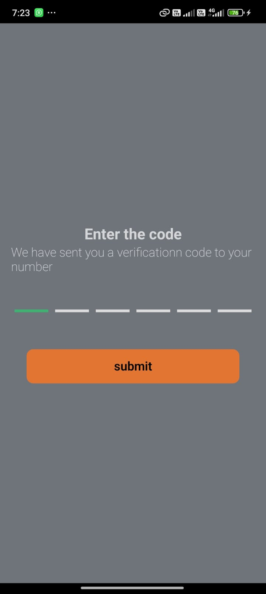

Figure 4.6 OTP Screen

## Forget Password Screen

The OTP (One - Time Password) screen is very critical to verify the identity of a user doing something sensitive or recovering his/her account. Using AWS SNS - Simple Notification Service for sending OTP SMS or Email in React Native with AWS. Setting up AWS SNS and integration with the React Native App using a AWS Amplify SDK. When a user triggers an OTP based action, generate an OTP and send it to the user's registered phone number or email (through AWS SNS). The OTP screen must have a text area, where the user should enter the received OTP and a submit button to validate it. After getting the code, the Reset Password screen should open for that user to enter the code and a new password. The code entered in the app should then be checked and the password changed using AWS Cognito.

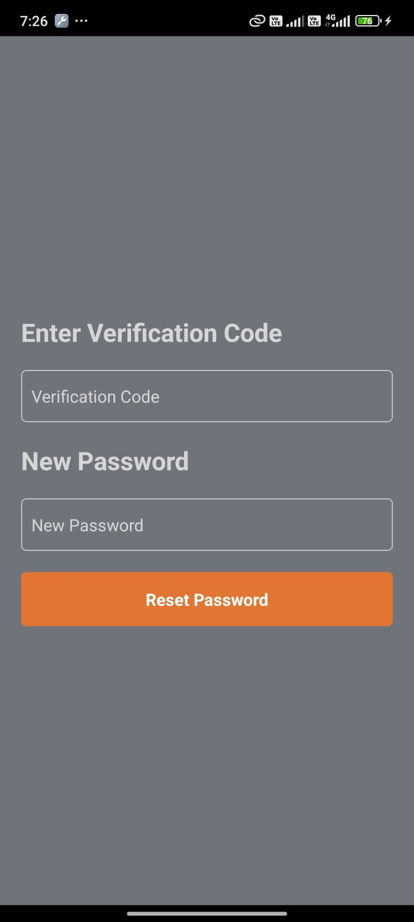

Figure 4.7 Forget Password Screen

## Reset Password Screen

The Reset Password screen allows users to set a new password after receiving a password reset code. In React Native with AWS, this screen works in conjunction with the Forget Password screen. The Reset Password view will contain input fields for the reset code, the new password and a submit button. When your user will enter this information and submit, your app should make the call AWS Cognito to check reset code entered and update the password. If it goes well the user should be redirected to a login screen. If the reset does not go through, display an alert telling the user to re-enter information, along with an appropriate error message.

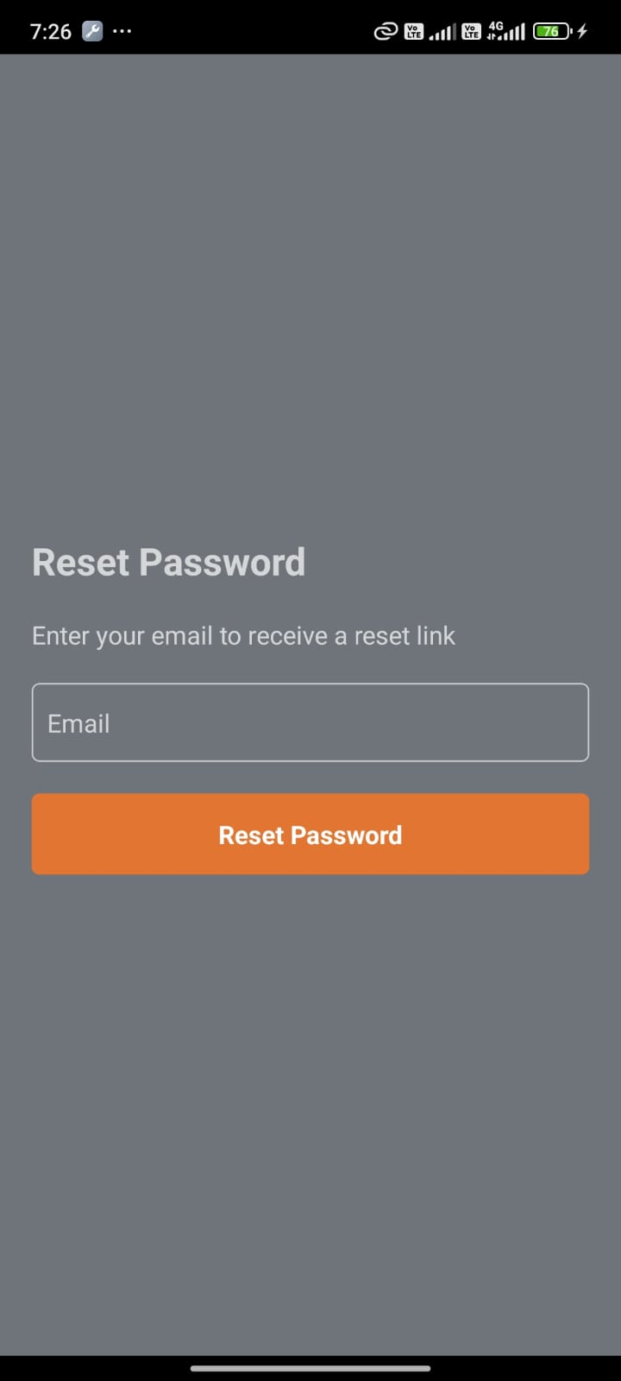

Figure 4.8 Reset Password Screen

## Goat Health Monitoring Device

Monitoring each goat is a ridiculously challenging task for a farmer to do. It is a time-consuming and slow process, and it has also increased labour, which has increased costs. This device will be a collar that provides real-time data which helps to monitor the cattle automatically. It decreases labour and faster monitoring.

The wearable device will consist of a node that includes the following components:

* Temperature Sensor (DS18B20)
* Accelerometer (ADXL 345)
* Pulse Oximeter (MAX30102)
* Gas Sensor (MQ135)
* Temperature and humidity (DHTT22)
* ESP 32

Temperature sensor is being used to take readings for goat’s body temperature from its neck. However, temperature can be measured from various areas positions in goat, but the actual task is to make sure that the sensor is not taking ambient readings. To make it more accurate and reliable, the sensor needs to be insulated properly as it is being exposed only to its skin so that it can measure the body temperature of specific goat. The temperature sensor is wrapped around the neck of the goat under the collar so that it can take proper measurements of body temperature. The accelerometer is not just used to detect cattle’s jaw movement it will also be detecting leg movements. The accelerometer is placed close to the jaw of the cattle on its collar measuring its jaw movement. The gas sensor is used to detect the presence of the gas acetone which is exhaled through the cattle’s nose. It is used to figure out whether the cattle are under stress or unwell. As it is not possible to interface this sensor inside its nose. So, instead, a moulded wire can be used to place the sensor close to its nose so that it can be exposed to this gas whenever it is there to detect it successfully.

# Evaluation

This research uses a real-time dataset previously used in recent research on an intelligent cattle health monitoring system [26] with the addition of our own collected dataset with added labels to cover a wide spectrum of diseases. The data was collected from cows under the supervision of a veterinary doctor for specific diseases often found in the local farm animals from various locations in Punjab, Pakistan. The data is heterogeneous in nature, which means the distribution of the data in datasets from different locations is uneven. A dataset from one location can contain more examples for a label which a dataset from another location might not have. Data standardization is crucial to train a Machine Learning model; otherwise, it may result in poor performance. During the pre-processing phase, the data was converted to sparse categorical data using a Label Encoder to convert each categorical value into a numeric value and One-Hot Encoding to split the output column into multiple columns depending on the initial value in the dataset.

## Comparative Analysis

The performance of five machine learning models (Decision Tree, Random Forest, Gradient Boosting, Neural Network and Gaussian Naive Bayes) were compared in this thesis. This analysis will target their training and test error, accuracy and efficiency in general for said performance metrics per different classification tasks.

Table 5.1 Overview of Model Performances

|  |  |  |  |
| --- | --- | --- | --- |
| **Model** | **Accuracy (%)** | **Training Error (%)** | **Test Error (%)** |
| Decision Tree | 91.51 | 0.00 | 8.49 |
| Random Forest | 96.22 | 0.00 | 3.78 |
| Gradient Boosting | 95.47 | 2.60 | 4.53 |
| Neural Network | 94.24 | 5.76 | 5.76 |
| Gaussian Naive Bayes | 93.75 | 6.58 | 6.25 |

### Analysis

Both Random Forest and Gradient Boosting models are well-fitted with good predictive capabilities and the lowest test error thus generalizability also stands out in these two. Random Forest performs very well on the dataset with almost 100% accuracy and a very low error rate on unseen data. Since Decision Trees have no training error but also a high-test error, which is indicative of an overfit, meaning that the resulting model captures the noise in our data inherent to the training set and thus does not generalize well on new, unseen examples. However, neural networks and Gaussian naive Bayes have moderate accuracy and much greater error which infer some difficulties in capturing the true patterns in a manner as good as ensemble models.

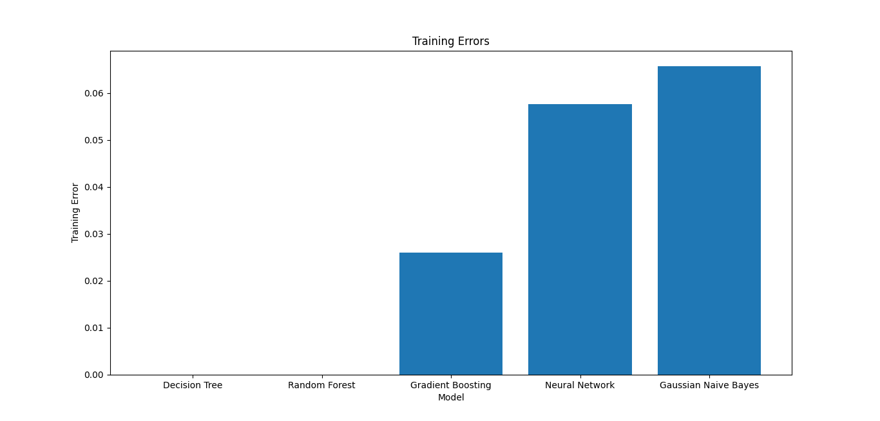

Figure 5.1 Training Errors

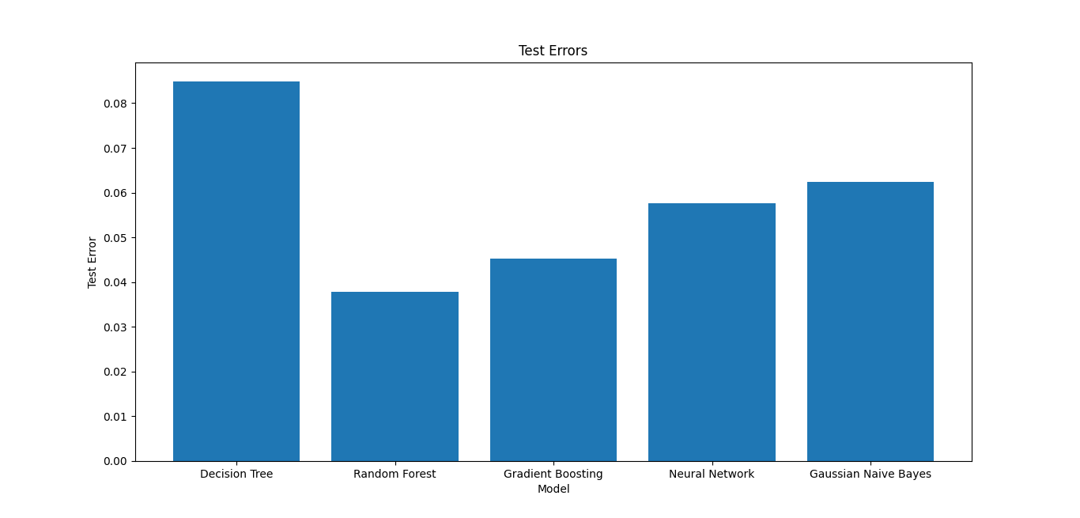

Figure 5.2 Test Errors

In the above single Decision Tree case overfit our data, whereas in Ensemble Techniques, being a group of models that are constructed well to reduce both the bias and variance at an average better prediction are made; so, it is more robust. For Neural Networks, we obtained a balance training and test error that may be further improved through hyperparameter tuning or adding more data/features. The somewhat elevated error rates in the plots above suggest that unequivocal, strict independence is not something we can take for granted from these predictions - though again, I would submit that they are more than good enough to win a dressage competition (and note that if this were a horse race, this classifier would have still come in second). Instead, ROC curve analysis will tell you about the trade-off between true positive and false positive that is obtainable by changing the threshold. All models other than the Decision Tree have AUCs close to 1, indicating excellent discrimination between classes.

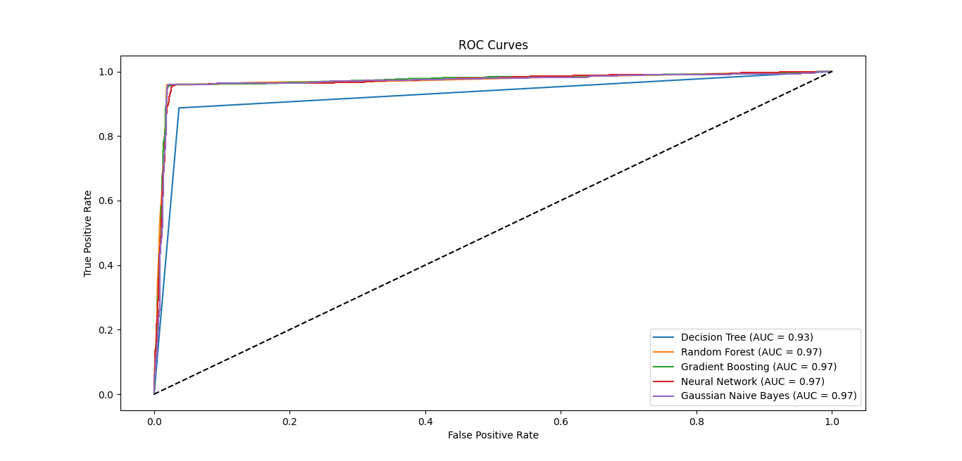

Figure 5.3 ROC Curve

Based on the need to balance robustness and accuracy, Random Forest emerges as somewhat of a holy grail due to its low-test error at high accuracy. However more hyperparameter tuning and feature engineering may be needed to for models such as Neural Networks or Gaussian Naive Bayes, etc. Cross-validation methods are a good way to evaluate model stability and replicate results across different pockets of data. Based on the comparison, it may be concluded that ensemble methods, and particularly Random Forests perform best in managing high-dimensional context data with a better accuracy and not suffering from overfitting. This analysis gives an insight one how well a model performs and can help in selecting the right models to deploy out onto production.

Table 5.2 Comparison of Random Forest with Existing Work

|  |  |  |
| --- | --- | --- |
| Aspect | Results | Literature Review |
| Accuracy | 96.22% | High accuracy generally reported in similar health monitoring and agricultural applications. |
| Test Error | 3.78% | Lower test errors typically observed due to the model's ability to handle diverse datasets effectively. |
| Training Error | 0.00% | Often low to zero training error, indicating a good fit on training data without overfitting concerns in aggregated models. |
| Use-case | Health monitoring in a livestock context | Widely used for predictive health monitoring, environmental simulations, and decision support systems in agriculture. |
| Predictive Performance | Excellent ability to predict based on test metrics. | Noted for robust predictive performance and reliability in complex decision-making environments. |
| Robustness | Demonstrated minimal overfitting with real-world data. | Valued for its robustness across different studies, particularly in environments with high variability in data. |
| Generalization | Low test error indicates good generalization capabilities. | Often highlighted for generalizing well to new, unseen data, supporting its use in operational settings. |
| Data Handling | Effective in managing multi-feature datasets. | Excellently handles large and complex datasets with multiple input variables, a common theme in literature. |
| Modelling Complexity | Handles complex modelling scenarios effectively. | Frequently utilized in scenarios requiring complex data relationships and interactions among variables. |

## Random Forest Classifier

The Random Forest also models a classifier, but the model itself is specifically designed to accept heterogeneous data. The quality and the amount of data set from each location determine how accurate these models will be. Results on independent datasets for the independent datasets, the results of each trained model are represented in Table 1. In this case, the evaluation metrics for a machine learning model are precision, recall, F1-score, and support. True Positives are instances that were correctly predicted as positive, and False Positives are instances that were falsely flag as positive (predictions misclassifying) Precision score lies between 0 to 1, the more precision the less false positive cases. The precision = 1 for all classes (CCPC, HS, Healthy, High fever) in all datasets on which models are trained. This means that all the predictions for these classes were right 100% of the time.

Recall, (5.1) another name for this is "specificity" or "true positive rate" meaning - it measures a model ability to predict everything + predicted nothing. A high recall means the model accurately labels positive instances and reduces false negatives. The recall for the classes CCPC, HS, Healthy are 1 and we also have a recall of 1 for the class high fever for all the trained models.

The F1-score (5.2) is the harmonic mean of two other tests - precision and recall - turned into a single metric. This can be very useful if we have an imbalanced class. F1-score is 1 for classes CCPC, HS, Healthy and High fever for all trained models.

.

Whereas (5.3) the support is the number of occurrences of each class in the dataset which helps identifying any imbalances. In the dataset, that class Healthy has the highest support value of 1835 for the model trained and that class High fever has the minimum support value of 691. Support is just the count of occurrences in each class in the data set and there is no formula or computation in calculating support.

Table 5.3 Accuracy for the model trained

|  |  |  |  |  |
| --- | --- | --- | --- | --- |
|  | **Precision** | **Recall** | **F1-Score** | **Support** |
| Class 0 (Healthy) | 0.97 | 0.99 | 0.98 | 1760 |
| Class 1 (High Fever) | 0.95 | 0.96 | 0.95 | 681 |
| Class 2 (CCPC) | 0.78 | 0.78 | 0.85 | 87 |
| Class 3 (HS) | 0.81 | 0.81 | 0.86 | 145 |
| Accuracy | - | - | 0.96 | 2673 |
| Macro Avg | 0.94 | 0.88 | 0.91 | 2673 |
| Weighted Avg | 0.96 | 0.96 | 0.96 | 2673 |

In above table 5.3, the model delivered good performance metrics over all the classes. Class 0 (Healthy), accurate: 97%, recall: 99%, F1-score: 98%, support: 1760 instances Class 1 (High Fever) performed very well with a precision of 0.95, recall of 0.96 and F-1 score of 0.95 however was slightly lower than the figures obtained from standard model which consists of total 681 instances. But this performance dropped slightly to the 0.78 precision and recall rates of items for Class 2 (CCPC) and 0.81 precision and recall classes for Class3 (HS), with f1-scores 0f 0.85 and 0.86, supporting, respectively, by 87 and 145 instances. The model managed 2673 instances with an accuracy of 0.96 overall. The macro metrics were 0.94,recall=0.88, and f1-score=0.91 and the weighted average metrics were constant across precision,f1-score =0.96, but recall= 0.95 for the word-based experiments are document classification.

### Random Forest Accuracy vs Number of Trees

Figure 5.1 shows the Random Forest accuracy vs Number of Trees It means this accuracy starts at a very high level even with a smaller no of trees which shows very solid performance from the beginning. Accuracy meanwhile stays about as high with minor fluctuations and with the increase in the number of trees accuracy raised over peaks again at an around 400 trees, then decide to fall, but also start to grow up till it reach 1000 trees. This pattern indicates that Random Forest continues to maintain its high accuracy but the returns of increases in number of trees diminish after a certain point, alluding to a bias-variance trade-off.

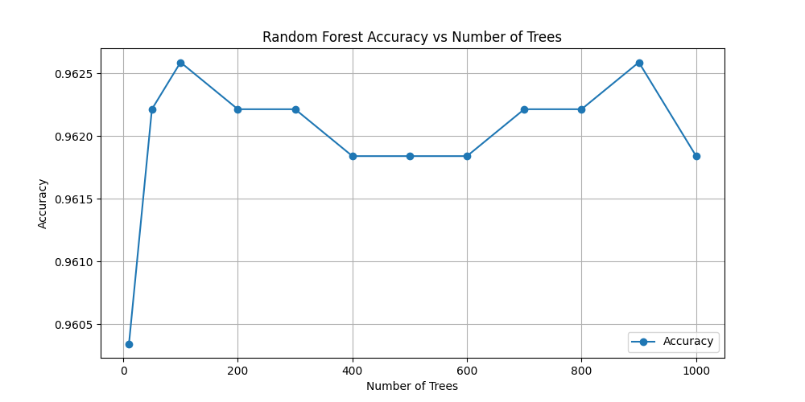

Figure 5.4 Random Forest Accuracy vs Number of Trees

### Random Forest Error Rate vs Number of Trees

The graph titled "Random Forest Error Rate vs Number of Trees" in the above figure 5.2 shows how the error rate of Random Forest classifier changes when we change the number of trees. Firstly, though the error rate is quite high to start off, it falls rapidly until about 100 trees, this means that already with few endogenous variables the model becomes more accurate than with many [running trees] for classification. Now as we add more trees the error rate starts stabilizing with some slight ups and downs (but it's hovering around a low value), which means that adding complexity help the model up to a point. But get those tree counts up toward 1,000 and the error starts to creep back in, implying that we might be past the point of overfitting his model or certain levels of diminishing returns instead where the error is a concern. This graph very nicely demonstrates the trade-off point; there is a sweet balance between too few trees and far too many, where increasing more trees does not always make the model better but essentially results in performance degradation

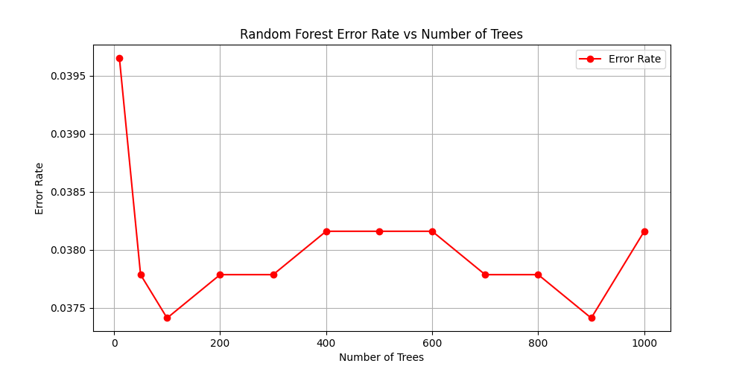

Figure 5.5 Random Forest Error Rate vs Number of Trees

## Goat’s Digital Twin

The digital twin of a goat is an advanced virtual replica of a real goat that provides across-the-board health and behaviour monitoring and analysis. The digital twin is built by absorbing enormous amounts of data from many sensors placed on the goat including GPS collars, accelerometers, temperature & heart activity monitors. These sensors superficially acquire the real-time data all around, transmit it to a central processing system. This data is fed into advanced algorithms and machine learning models which combine to produce a sophisticated digital rendition of the goat, which changes as it moves throughout complicated environments. This virtual model in turn reproduces the physical and behavioural characteristics of the goat, so that farmers (or veterinarians) can closely follow its evolution.

Digital twin tech is good for predictive analytics and early health detection. The digital twin, through continuously monitoring sensor data, can detect changes in movement which might signify lameness or a change of temperature that indicates fever. Models trained by machine learning on historical data can provide a probability of each disease and increase the possibility of right treatment in time. It can also run different scenarios of simulated emulation based on various factors like diet changes or environmental conditions, so that farmers can take data-driven decisions to improve goat health & productivity.

Additionally, the goat digital twin benefits goat management and care with insights to improve decisions based on data. User-friendly interfaces in farmers' devices provide alerts and recommendations delivered based on real-time data analysis available from the digital twin. It can even interface with farm management systems to provide real-time monitoring of an animal's health records, breeding status and performance data. In the bigger picture, this whole process adds an extra layer of health and well-being for each goat that helps make the farming operation more scalable, sustainable and ultimately profitable. Farmers can take care of the goats in a better way, to get early disease detection and resource management. - Use digital twin technology for your goat herd.

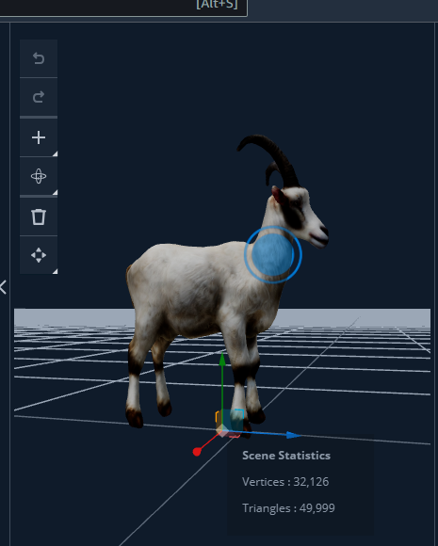

Figure 5.6 Digital Twin of Goat

## Mobile Application

The mobile application developed using the MERN stack provides real-time health monitoring results for goats. The application fetches data from a MongoDB database, processes it through an Express.js and Node.js backend, and delivers the results to the React frontend. Displaying vital health parameters such as temperature (40.53238°C), humidity (26.32422%), air quality (19.87232), SpO2 levels (99.53319%), body temperature (38.97731°C), heart rate (74 bpm), and accelerations along the X, Y, and Z axes (-9.4432, 6.4864, and -2.1182 respectively), the app provides a comprehensive overview of the goat's health status. The health status is indicated as "Healthy," reassuring the user of the goat's well-being. This efficient and user-friendly application ensures timely monitoring and enhances overall livestock management.

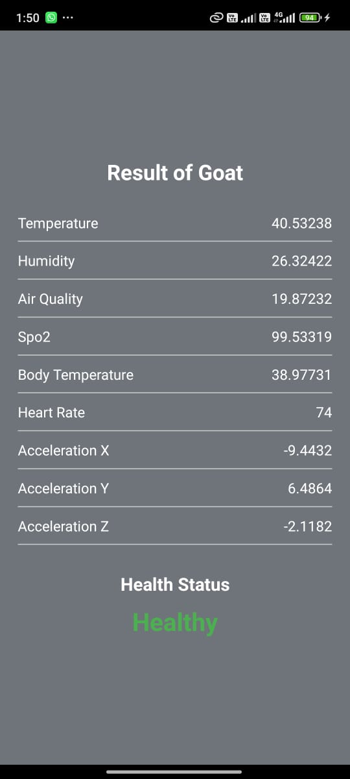

Figure 5.7 Result Screen

# Conclusion & Future Work

## Conclusion

The proposed goat health monitoring system demonstrates significant potential in revolutionizing animal husbandry through advanced technologies. By leveraging a comprehensive network of sensors and machine learning algorithms, the system can accurately predict and diagnose diseases such as Foot and Mouth Disease (FMD) and High Fever in goats. The selection of specific physiological parameters, including temperature, movement, acetone detection, and bellowing, ensures precise and reliable disease detection. The integration of a wireless sensor network further enhances data collection and transmission efficiency, enabling real-time monitoring and early intervention. The application of the Random Forest classifier has yielded outstanding results, with the highest possible scores in precision, recall, and F1 metrics, indicating the robustness and reliability of the system.

Moreover, the digital twin technology provides a sophisticated virtual representation of each goat, facilitating continuous health and behaviour monitoring. This enables farmers and veterinarians to make data-driven decisions, improving the overall management and welfare of the goats. The successful implementation of this system not only enhances the health monitoring process but also contributes to sustainable farming practices by optimizing resource usage and reducing environmental impact. Ultimately, this project underscores the transformative potential of integrating IoT, machine learning, and digital twin technologies in modern agriculture, paving the way for more efficient and productive livestock management.

## Future Ideas

1. **IoT and Block Chain Integration:** Integrate IoT devices with block chain technology to ensure secure and transparent data management. This will enhance trust and reliability in the monitoring system, especially for large-scale farms with multiple stakeholders.
2. **Integration of Advanced Machine Learning Models:** Enhance the existing system by incorporating advanced machine learning models such as deep learning algorithms to improve the accuracy and predictive capabilities of the goat health monitoring system.
3. **Expansion to Other Livestock:** Adapt and expand the current monitoring system to include other livestock such as cattle and sheep. This will broaden the applicability of the system and provide comprehensive solutions for various types of farms.

# References

|  |  |
| --- | --- |
| [1] | F. o. t. United-Nation, "Goats," 10 january 2023. [Online]. Available: https://www.fao.org/livestock-systems/global-distributions/goats/en/. |
| [2] | F. J. Olea-Popelka, "Precision livestock farming in Argentina," 2019. [Online]. Available: https://acsess.onlinelibrary.wiley.com/doi/abs/10.1002/agj2.21346. |
| [3] | I. T. Mistry, "Digital twin technology for livestock health monitoring," 2023. |
| [4] | S. Neethirajan, "digital twin in livestock farming," 2 january 2021. [Online]. Available: https://www.mdpi.com/2076-2615/11/4/1008. |
| [5] | Y. e. a. Zhang, "A smartphone-based system for automatic stress detection in dairy cows," 2018. |
| [6] | L. e. a. Yuan, " On-line and real-time monitoring of greenhouse gases in intensive animal houses. Sensors," 2012. |
| [7] | A. e. a. Jensen, "Digital twins for livestock," *A vision for improving animal welfare and food security. Computers and Electronics in Agriculture,* 2020. |
| [8] | Y. e. a. Rao, "On-farm welfare monitoring system for goats based on Internet of Things and machine learning," 2020. |
| [9] | "FederatedLearning", "Wekipedia," [Online]. Available: https://en.wikipedia.org/wiki/Federated_learning. |
| [10] | S. K. Mudziwepasi and M. S. Scott, "Asssesment of wireless sensor netwok," 2014. |
| [11] | A. R. B. L. N. R. M. S. &. B. U. Nardone, "Effects of climate changes on animal production and sustainability of livestock systems," *Nardone, A,* vol. 130, no. 1-3, pp. 57-69, May, 2010. |
| ss[12] | "Global Trend in Goat Farming," *Peacock, C,* Vols. 60(1-2), no. 179-186, p. Goats – A pathway out of poverty. Small Ruminant Research, 2005. |
| [13] | T. H. Mérta Alexy, "Precision Solutions in Livestock Farming – feasibility and applicability of digital data collection," in *IEEE 10th Jubilee International Conference on Computational Cybernetics and Cyber-Medical Systems (ICCC)*, Reykjavík, Iceland, 06-09 July 2022. |
| [14] | M. P. K. P. K. S. M. K. Devaki K, "Traditional sheep and goat farming practices of Tamil Nadu," *Krishi Vigyan,* vol. 9, no. 2, pp. 238-244, 2021. |
| [15] | Y. Rao, "On-farm welfare monitoring system for goats based on Internet of Things and machine learning," *Yuan Rao, Min Jiang, Wen Wang, Wu Zhang and Ruchuan Wang,* July 18, 2020. |
| [16] | D. E, "Data analysis supports monitoring and surveillance of goat health and welfare in the Netherlands," *Dijkstra E, van der Heijden M, Holstege M, Gonggrijp M, van den Brom R, Vellema P,* vol. 213, April 2023. |
| [17] | S. Neethirajan, "Recent advances in wearable sensors for animal health management," *Suresh Neethirajan,* vol. 12, pp. 5-29, February 2017. |
| [18] | G. Morota, "BIG DATA ANALYTICS AND PRECISION ANIMAL AGRICULTURE SYMPOSIUM: Machine learning and data mining advance predictive big data analysis in precision animal agriculture," *Gota Morota, Ricardo V Ventura, Fabyano F Silva, Masanori Koyama, Samodha C Fernando,* vol. 96, no. 4, p. 1540–1550, April 2018. |
| [19] | M. Bonneau, "Automatic activity tracking of goats using drone camera," *Jehan-Antoine Vayssade, Rémy Arquet, Mathieu Bonneau,* vol. 162, pp. 767-772, July 2019. |
| [20] | D. W. Bailey, "Use of GPS tracking collars and accelerometers for rangeland livestock production research," *Derek W Bailey, Mark G Trotter, Colt W Knight, Milt G Thomas,* vol. 2, no. 1, pp. 81-88, February 2018. |
| [21] | B. U. Bauer, "A Q fever outbreak on a dairy goat farm did not result in Coxiella burnetii shedding on neighboring sheep farms – An observational study," *Benjamin Ulrich Bauer, Thea Louise Herms, Martin Runge, Martin Ganter ,* vol. 215, October 2022. |
| [22] | M. v. Asseldonk, "Economic aspects of Q fever control in dairy goats," *M.A.P.M. van Asseldonk, D.M. Bontje, J.A. Backer, H.J.W.van Roermund , R.H.M. Bergevoet ,* vol. 121, no. 1-2, pp. 115-122, September 2015. |
| [23] | D. D. Lazarus, "Clinical presentation of FMD virus SAT1 infections in experimentally challenged indigenous South African goats," *David D. Lazarus, Paidamoyo B. Mutowembwa , Mohamed M. Sirdar , Thapelo M. Rametse, Livio Heath, Pamela A. Opperman , Richard E.J. Burroughs, Geoffrey T. Fosgate,* vol. 180, pp. 15-20, November 2019. |
| [24] | M. I. Yatoo, "Contagious caprine pleuropneumonia – a comprehensive review," *Mohd. Iqbal Yatoo, Oveas Raffiq Parray, Shah Tauseef Bashir, Muheet, Riyaz Ahmed Bhat, Arumugam Gopalakrishnan, Kumaragurubaran Karthik, Kuldeep Dhama, and Shoor Vir Singhf,* vol. 39, p. 1–25, 2019. |
| [25] | S. Neethirajan, "Digital Twins in Livestock Farming," *Suresh Neethirajan, Bas Kemp,* vol. 11, no. 4, 2021. |
| [26] | K. R. Žalik, "A Review of Federated Learning in Agriculture," *Krista Rizman Žalik and Mitja Žalik,* vol. 23, no. 23, 2023. |
| [27] | "Temperatures," University of Glasgow School of Veterinary Medicine, [Online]. Available:https://www.gla.ac.uk/t4/~vet/files/teaching/clinicalexam/examination/info/temperatures.html#:~:text=The%20rectal%20temperature%20reference%20range,temperature%20outside%20of%20these%20ranges. |
| [28] | H. Yuan, L. Yang, Y. Zhan, Y. Zhang, and L. Xu, "Characteristic Analysis of DS18B20 Temperature Sensor in the High-voltage Transmission Lines' Dynamic CapacityIncrease,"ResearchGate,2014.[Online].Available:https://www.researchgate.net/publication/271289226_Characteristic_Analysis_of_DS18B20_Temperature_Sensor_in_the_Highvoltage_Transmission_Lines'_Dynamic_Capacity_Increase. |
| [29] | "How to Use DS18B20 Temperature Sensor - Arduino Tutorial," Instructables, [Online]. Available: https://www.instructables.com/How-to-use-DS18B20-Temperature-Sensor-Arduino- Tuto/. |
| [30] | "DS18B20 Arduino Tutorial," Last Minute Engineers, [Online]. Available: https://lastminuteengineers.com/ds18b20-arduino-tutorial/ |
| [31] | González, A., Olazagoitia, J. L., & Vinolas, J. (2018). A Low-Cost Data Acquisition System for Automobile Dynamics Applications. Sensors (Basel, Switzerland), 18(2). https://doi.org/10.3390/s18020366 |
| [32] | "How to interface Seeeduino Xiao, ESP8266-01, and ADXL345," Arduino Forum, Jul. 3, 2023. [Online]. Available: https://forum.arduino.cc/t/how-to-interface-seeeduino-xiao-esp8266-01-and-adxl345/1052492/15. |
| [33] | "ADXL345 - Digital Accelerometer," Analog Devices, [Online]. Available: https://www.analog.com/en/products/adxl345.html#product-overview. |
| [34] | M. Yaghoubi, K. Ahmed, and Y. Miao, "Wireless Body Area Network (WBAN): A Survey on Architecture, Technologies, Energy Consumption, and Security Challenges," J. Sensor Actuator Networks, vol. 11, no. 4, p. 67, Apr. 2022, doi: 10.3390/jsan11040067. |

.

# Appendix A: Sustainable Development Goals Achievement

|  |  |  |  |  |  |  |  |
| --- | --- | --- | --- | --- | --- | --- | --- |
| **SDGs** | **Included/ Not included** | **If Included Inclusion Level as: Partial, Average, or Major** | **Goal (s) of project that lie in the SDG** | **How goal (s) meet the criteria for SDG** | **Why goal (s) meet the criteria for SDG** | **Time spent in number of weeks** | **Additional Remarks/ Discussion** |
|  | Included | Major | Maintaining goot health to provide goat and minimize goat loss | A mobile application gives goat health details to the farm owners before it’s too late | Healthy goat open a lot of earning opportunities for farm owners | 6 | Majority farm owners are suffering due to not being able to afford healthcare for goat and facing constant losses |
|  | Included | Major | Eradicate hunger and provide and have stable food supply | goat health is constantly monitored, and farm owners are warned in the early stage of disease to save the goat | goat loss is minimized and makes it easier to fulfil market demand | **4** | As per growing population the market demand is constantly increasing and needs to be taken care of **goats** |

# Appendix B: HDL or C Source Code

#include <DHT.h>

#include <OneWire.h>

#include <DallasTemperature.h>

#include <Wire.h>

#include <Adafruit_Sensor.h>

#include <Adafruit_ADXL345_U.h>

#include <WiFiClientSecure.h>

#include <PubSubClient.h>

#include <ArduinoJson.h>

#include "WiFi.h"

#include "secrets.h" // Assumes you have a secrets.h file with WiFi and AWS IoT credentials

#include "MAX30105.h"

#include "heartRate.h"

// Sensor definitions and initializations

#define DHTPIN 14 // Digital pin for DHT22

#define DHTTYPE DHT22 // DHT22 sensor type

#define MQ_PIN 34 // Analog pin for MQ-135

const int oneWireBus = 4; // OneWire bus for DS18B20

DHT dht(DHTPIN, DHTTYPE);

OneWire oneWire(oneWireBus);

DallasTemperature sensors(&oneWire);

MAX30105 particleSensor;

// Heart rate measurement variables

const byte RATE_SIZE = 4;

byte rates[RATE_SIZE];

byte rateSpot = 0;

long lastBeat = 0;

float beatsPerMinute;

int beatAvg;

int correctionfactorT = 0;

// Initialize the ADXL345 accelerometer

Adafruit_ADXL345_Unified accel = Adafruit_ADXL345_Unified(12345);

WiFiClientSecure net;

PubSubClient client(net);

// Global variables for sensor data

float temperature, humidity, airQuality, bodyTemperature, spo2;

sensors_event_t event; // Declare event as a global variabl

#define AWS_IOT_PUBLISH_TOPIC "sub"

#define AWS_IOT_SUBSCRIBE_TOPIC "sub"

void connectAWS() {

WiFi.mode(WIFI_STA);

WiFi.begin(WIFI_SSID, WIFI_PASSWORD);

Serial.println("Connecting to Wi-Fi");

while (WiFi.status() != WL_CONNECTED) {

delay(500);

Serial.print(".");

}

// Configure WiFiClientSecure to use the AWS IoT device credentials

net.setCACert(AWS_CERT_CA);

net.setCertificate(AWS_CERT_CRT);

net.setPrivateKey(AWS_CERT_PRIVATE);

// Connect to the MQTT broker on the AWS endpoint we defined earlier

client.setServer(AWS_IOT_ENDPOINT, 8883);

// Develop a message handler

client.setCallback(messageHandler);

Serial.println("Connecting to AWS IOT");

while (!client.connect(THINGNAME)) {

Serial.print(".");

delay(100);

}

if (!client.connected()) {

Serial.println("AWS IoT Timeout!");

return;

}

// Subscribe to a topic

client.subscribe(AWS_IOT_SUBSCRIBE_TOPIC);

Serial.println("AWS IoT Connected!");

}

void publishMessage() {

StaticJsonDocument<512> doc;

doc["temperature"] = temperature;

doc["humidity"] = humidity;

doc["airQuality"] = airQuality;

doc["bodyTemperature"] = bodyTemperature;

doc["heartRate"] = beatAvg;

doc["spo2"] = spo2;

doc["accelerationX"] = event.acceleration.x;

doc["accelerationY"] = event.acceleration.y;

doc["accelerationZ"] = event.acceleration.z;

char jsonBuffer[512];

serializeJson(doc, jsonBuffer);

client.publish(AWS_IOT_PUBLISH_TOPIC, jsonBuffer);

}

void messageHandler(char* topic, byte* payload, unsigned int length) {

Serial.print("incoming: ");

Serial.println(topic);

StaticJsonDocument<200> doc;

deserializeJson(doc, payload);

const char* message = doc["message"];

Serial.println(message);

void setup() {

Serial.begin(115200);

dht.begin();

sensors.begin();

pinMode(MQ_PIN, INPUT);

// Initialize ADXL345 accelerometer

if(!accel.begin()) {

Serial.println("Ooops, no ADXL345 detected ... Check your wiring!");

while(1);

}

accel.setRange(ADXL345_RANGE_16_G);

// Initialize MAX30105 particle sensor

if (!particleSensor.begin(Wire, I2C_SPEED_FAST)) {

Serial.println("MAX30102 was not found. Please check wiring/power.");

while (1);

}

particleSensor.setup();

particleSensor.setPulseAmplitudeRed(0x0A);

particleSensor.setPulseAmplitudeGreen(0);

connectAWS();

}

unsigned long lastPublishMillis = 0;

const long publishInterval = 1000; // Interval at which to publish (milliseconds)

void loop() {

if (!client.connected()) {

connectAWS(); // Reconnect to AWS IoT if not connected

}

client.loop();

unsigned long currentMillis = millis();

// Check if it's time to publish the next message

if (currentMillis - lastPublishMillis >= publishInterval) {

lastPublishMillis = currentMillis;

// DS18B20 temperature reading

sensors.requestTemperatures();

float temperatureC = sensors.getTempCByIndex(0);

if (temperatureC == DEVICE_DISCONNECTED_C) {

Serial.println("Error: DS18B20 not connected!");

} else {

bodyTemperature = temperatureC + correctionfactorT; // Update global variable

Serial.print("Body Temperature: ");

Serial.print(bodyTemperature);

Serial.println("ºC");

}

// MQ-135 air quality reading

int sensorValue = analogRead(MQ_PIN);

airQuality = map(sensorValue, 0, 4095, 0, 100); // Update global variable

Serial.print("Air Quality: ");

Serial.print(airQuality);

Serial.println("%");

// DHT22 humidity and temperature reading

humidity = dht.readHumidity(); // Update global variable

temperature = dht.readTemperature(); // Update global variable

if (isnan(humidity) || isnan(temperature)) {

Serial.println("Failed to read from DHT sensor!");

} else {

Serial.print("Humidity: ");

Serial.print(humidity);

Serial.print("%, Temperature: ");

Serial.print(temperature);

Serial.println("°C");

}

// Accelerometer data reading

accel.getEvent(&event);

Serial.print("Acceleration - X: ");

Serial.print(event.acceleration.x);

Serial.print(" m/s^2, Y: ");

Serial.print(event.acceleration.y);

Serial.print(" m/s^2, Z: ");

Serial.print(event.acceleration.z);

Serial.println(" m/s^2");

// MAX30105 heart rate and SpO2 reading

long irValue = particleSensor.getIR();

long redValue = particleSensor.getRed();

if (checkForBeat(irValue)) {

long delta = millis() - lastBeat;

lastBeat = millis();

beatsPerMinute = (60.0 / (delta / 1000.0))+30;

if (beatsPerMinute < 255 && beatsPerMinute > 20) {

rates[rateSpot++] = (byte)beatsPerMinute;

rateSpot %= RATE_SIZE;

beatAvg = 0;

for (byte x = 0; x < RATE_SIZE; x++)

beatAvg += rates[x];

beatAvg = (beatAvg/RATE_SIZE);

}

beatAvg = beatAvg ;

}

if (irValue < 50000) {

Serial.println("No Pulse is Detected");

} else {

Serial.print("IR=");

Serial.print(irValue);

Serial.print(", BPM=");

Serial.print(beatsPerMinute);

Serial.print(", Avg BPM=");

Serial.println(beatAvg);

// Calculate SpO2

spo2 = calculateSpO2(redValue, irValue); // Update global variable

Serial.print("SpO2=");

Serial.print(spo2);

Serial.println("%");

}

// Read sensor data and publish to AWS IoT

publishMessage();

}

}

bool checkForBeat(long irValue) {

static long lastIRValue = 0;

bool beatDetected = (irValue > lastIRValue);

lastIRValue = irValue;

return beatDetected;

}

float calculateSpO2(long redValue, long irValue) {

float R = (float)redValue / (float)irValue;

float spo2 = 104 - 17 * R;

return spo2; }

# Appendix C: Hardware Schematic

# WhatsApp Image 2024-06-23 at 19

Figure 0.1 Hardware Schematic

# Appendix D: List of Hardware Components

* Temperature Sensor (DS18B20)
* Accelerometer (ADXL 345)
* Pulse Oximeter (MAX30102)
* Gas Sensor (MQ135)
* Temperature and humidity (DHTT22)
* Esp32